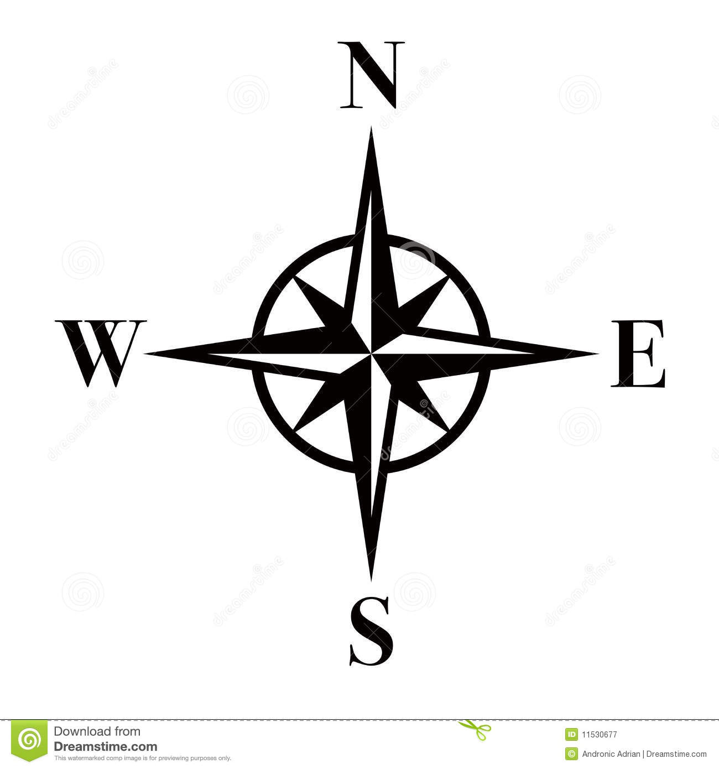

LABEL THE AFRO-EURASIA MAP:
Outline, lightly shade and label the following ancient civilizations:
Mesopotamia (yellow)
Indus Valley (green)
Shang Dynasty (red)
Egypt (purple)
Mycenaean (orange)

Draw in BLUE the following rivers:
Nile
Tigris
Euphrates
Indus
Ganges
Yellow
Yangzi

Mark where the Himalayan Mountains are with black

Label the Mediterranean Sea, Indian Ocean, Pacific Ocean in blue

Draw the Equator and label

