Trade: The Phoenicians

- Label the attached map using the atlases in the classroom or your phones
  - Locations (mark and label)
    - Byblos (Jubayl)
    - Tyre (Sur)
    - Sidon (Sayda)
    - Cadiz (Gades)
    - Iberian Peninsula
    - Anatolian Peninsula
    - Levant on the eastern coast of the Mediterranean Sea
    - Carthage (north of modern day Tunis)
    - Pillars of Hercules (Strait of Gibraltar)
    - SHADE AND LABEL the Phoenician colonies (750-600 BCE) GREEN
    - SHADE AND LABEL the Greek colonies (750-600 BCE) RED

  - Label bodies of water
    - Mediterranean Sea
    - Black Sea
    - Aegean Sea
    - Nile River
    - Red Sea

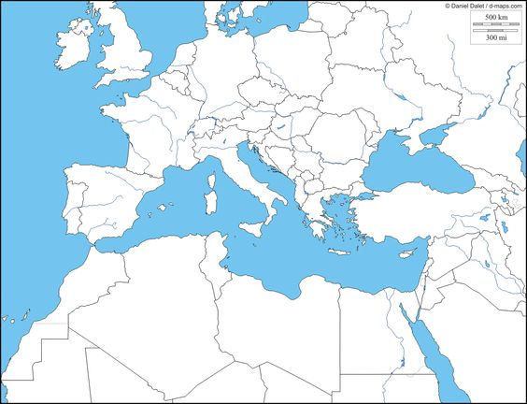
2. Read Handout 4.1 Trade: The Phoenicians and answer the questions below

- In what ways were the Phoenicians like today’s multinational business people?

- In what ways do modern business people spread Western culture as they do business abroad?

- In what ways do they transfer/exchange technology?

- In the middle of the 5th century BCE, the Phoenicians, according to the Greek historian Herodotus, made trips to Britain for tin, and, under orders from an Egyptian Pharaoh, circumnavigated (went around) Africa. Herodotus says that the Phoenicians claimed that, in order for them to make the trip around Africa, they had to stop, plant grain, wait for it to ripen, harvest it, and sail on. On a the map (in this packet), trace and LABEL the route the Phoenicians would have taken to circumnavigate Africa and the route they would have followed to reach Britain.

- Write an advertisement for a job during the 5th century BCE in the Phoenicia and the Phoenician Empire. Be creative - this isn’t an essay, it’s an ad to get someone to apply for the job! Pictures, slogans, etc. - something catchy! Use a separate piece of paper.
THINK ABOUT THE FOLLOWING THINGS:
  - What businesses/industries were there
  - What kind of positions may be in available
  - Describe what qualifications a candidate would need to be hired for this job.

