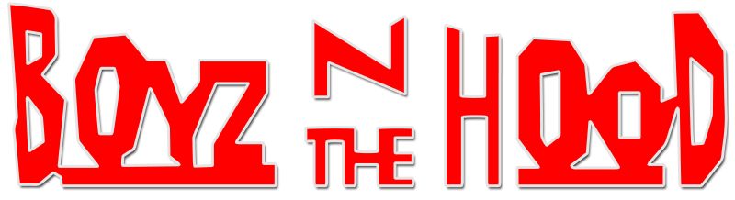
TASK 1: Based on what we have seen so far in class…
What has the director done to make Boyz n the Hood interesting and entertaining?

Who is this film aimed at?

List similarities you see between Ricky, Doughboy and Tre:
-
-
List differences:
-
-
TASK 2:
Producer Steve Nicolaides states: “The strength of the Black community is what makes this film strong. The script is sincere = more important- timely. This story is about our society today, and it’s important for everyone to take a look at what our society is doing to itself.”
Are the same problems with race and poverty here today?

Why do you think the film makers made this film?

TASK 3:
“One out of every 21 Black American males will be murdered. Most will die at the hands of another Black male.” - John Singleton
“My experience is a particular one, my struggles have been particular. My people have literally not been able to sit down and eat lunch at the same counter as you, or use the same water fountain. My mother and father told me stories from the South, where they saw people lynched, hanging from trees… those are different experiences from Whites and I don’t want to ignore that.” - Bill Duke (Director of “A Rage in Harlem”)
What happened in history that caused racism today?

TASK 4: Respect
The policeman might be described as “Black on the outside, White on the inside.” What does he mean?

At the party at Ricky’s house, Doughboy cuts in front of the girls. Tre tells them to let the girls get food first. Why do they treat the women differently?

Write down as many examples as you can think of where the characters show a lack of respect:
-
-
-
Task 5: Responsibility
There is a phrase that Doughboy utters towards the end of the film after his brother Ricky has been shot dead by a rival gang member. Tre and Doughboy bring Ricky’s body back to the house where Ricky’s mother shouts at Doughboy, “What did you do?” Doughboy replies, “I didn’t do nothing.”
Is it true that Doughboy “didn’t do nothing”? Do you think he is or is not responsible for Ricky’s death.

“I didn’t do nothin’” is heard throughout the film. You hear it in the absence of fathers, in Doughboy selling drugs that further corrupt his own neighborhood, in Ricky fathering a child when he can’t even support himself, in dropping out of school and condemning themselves to a life of petty (and not so petty) crime on the streets. Few characters in the ‘Hood’ take responsibility for their actions and their lives.

Suggest some possible reasons why the some of the characters feel like they can’t take responsibility:

Reflect on what we have talked about in class (notes from the power point on Milwaukee) and discuss the following idea:
“Black males have been deprived of the means to support their families by society. Their will and pride have been undermined resulting in them giving up trying.”
Do you agree or disagree with this statement?
Explain why or why not? Give an example
-
Give examples of how Furious guides Tre and teaches him responsibility:
-
Task 6: Cautionary Tale
“Black folks we’ve got to stick together otherwise this genocide is going to take its course.” – John Singleton
Genocide: “The international and systematic destruction of a national, racial, ethical or religious group.” - New Elizabethan Religious Dictionary
What does Singleton mean by this “genocide is going to take its course”?

Is the film’s message really that negative (pessimistic)?

List at least 1 way in the film that shows that the cycle of violence, poverty and ignorance might be broken:

Task 7:
Think of examples from the film that look like our communities in Madison or Wisconsin in general:
-
-
Give reasons why you think these problems occur:
-
-
How could society stop these problems from happening?

Task 8:
John Singleton states that “everyone sees themselves in this film”. Discuss whether you agree or disagree and why. (4 sentences minimum)

