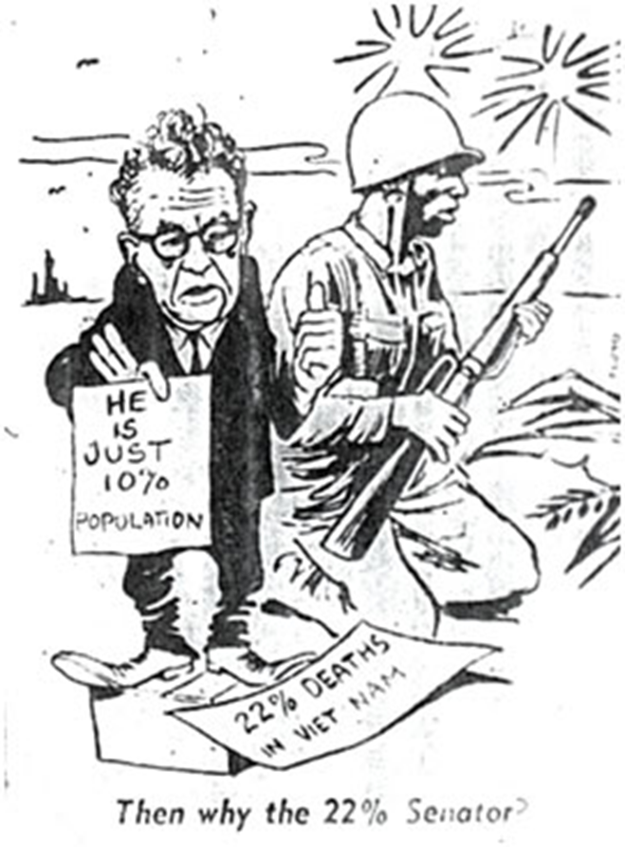
- What is this cartoon saying about who was fighting the war? What issue in particular?

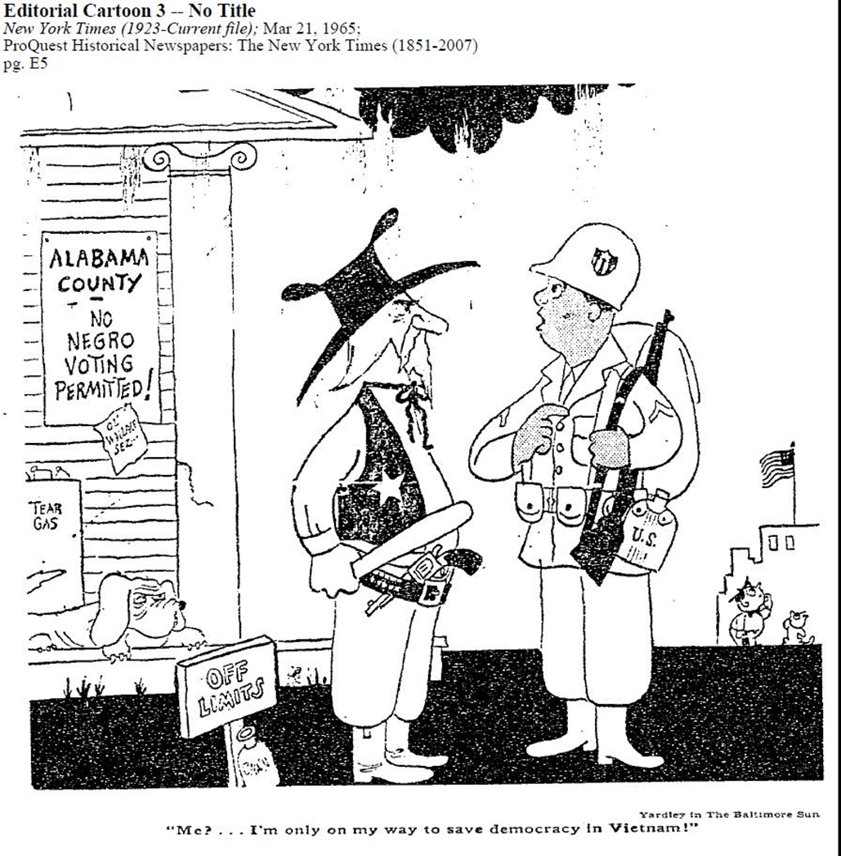
- What is “ironic” about this cartoon? What is going on at home versus the war?

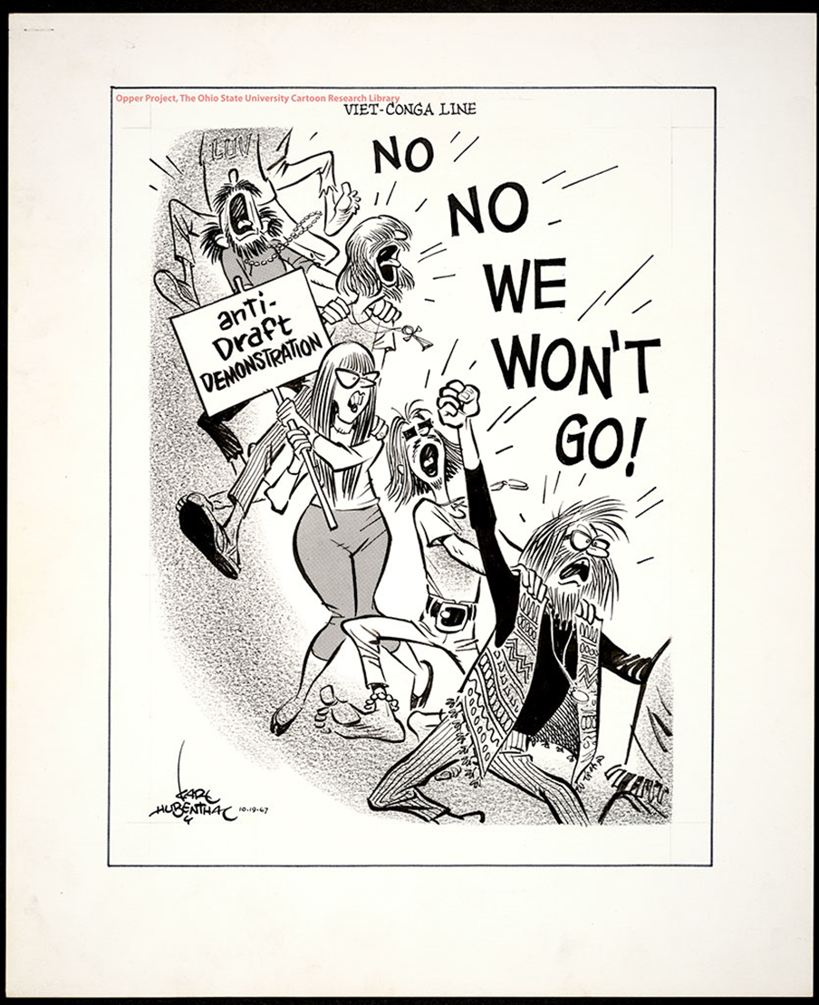

- How does this cartoon depict (show) protestors? Do you think this is accurate?

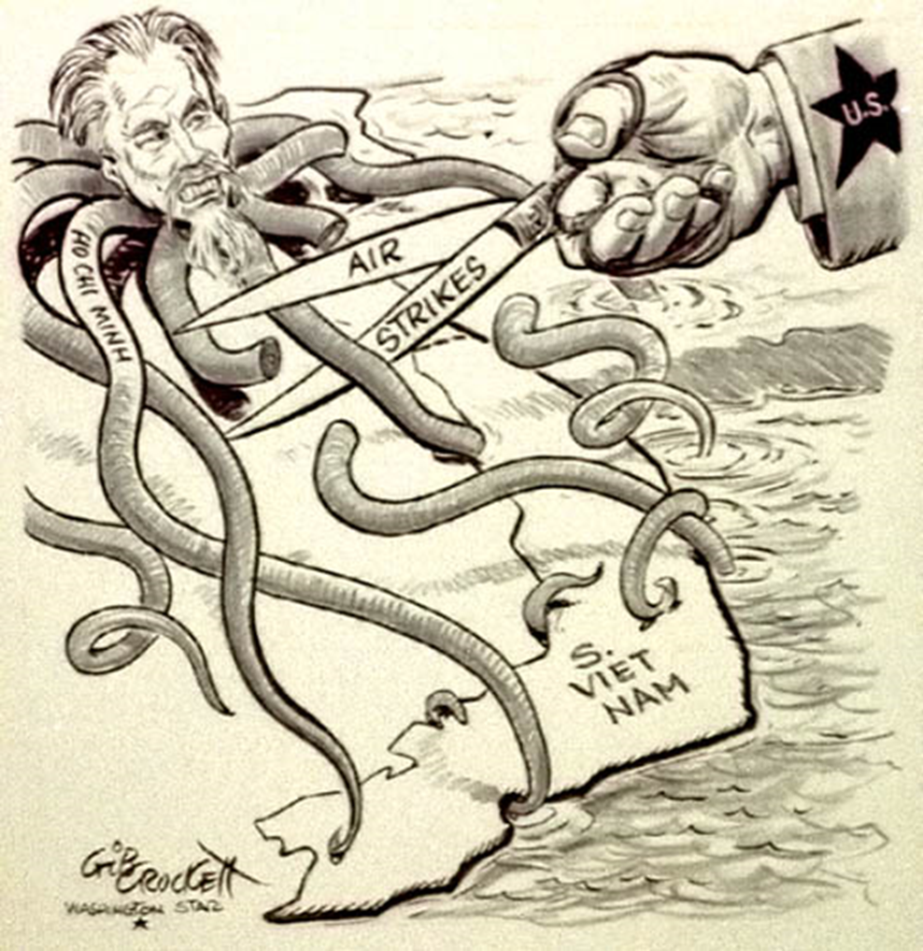
- Is this Pro/Anti US involvement in Vietnam? What does the octopus represent and what are we doing?

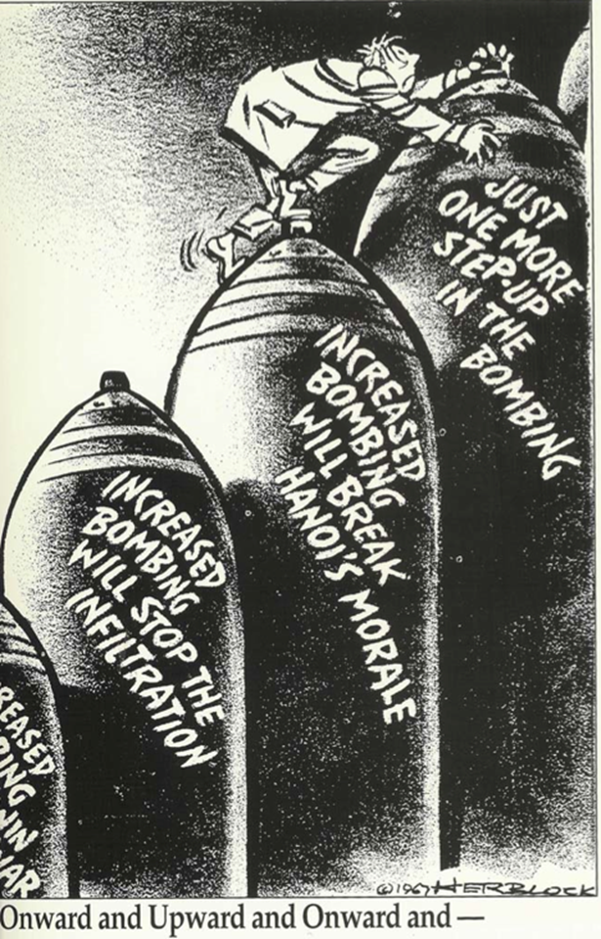
- What term comes to mind here? What particular strategy is this commenting on? Was it successful and what was our solution?

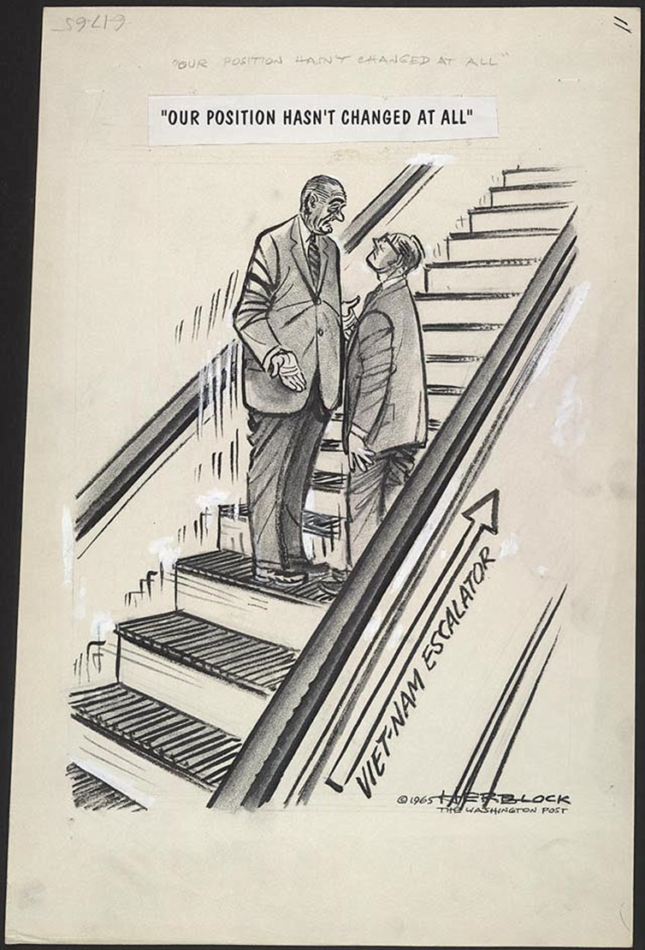
- What is this saying about our actual involvement versus what the government was saying?

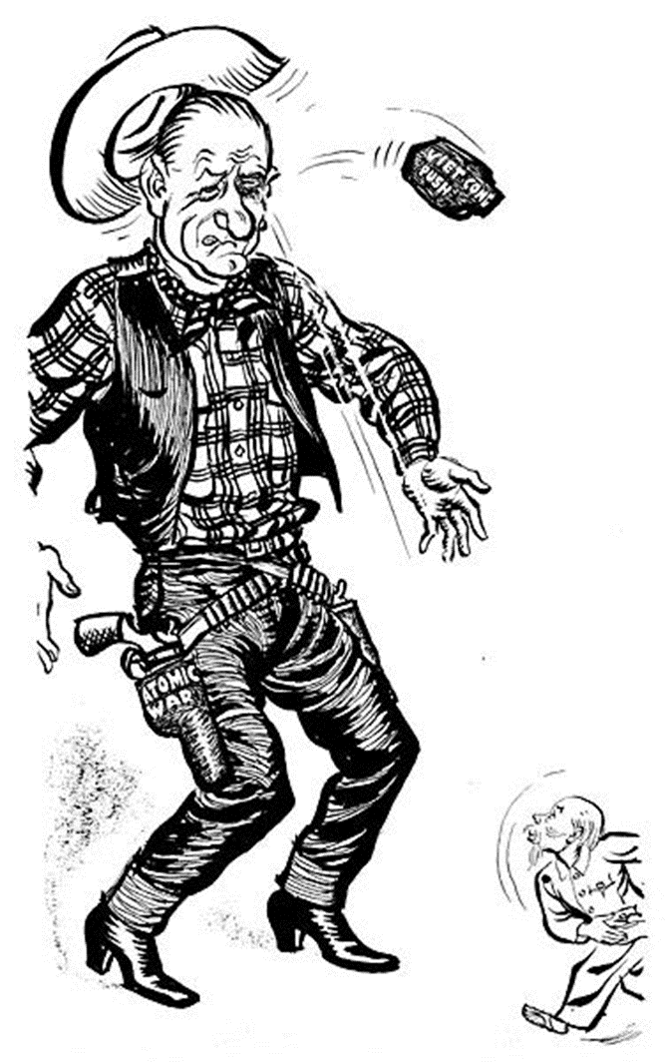
- What does this say about the attitude of the US? How did we see ourselves us versus the way the VC fought? Does the “big guy” always win the fight?

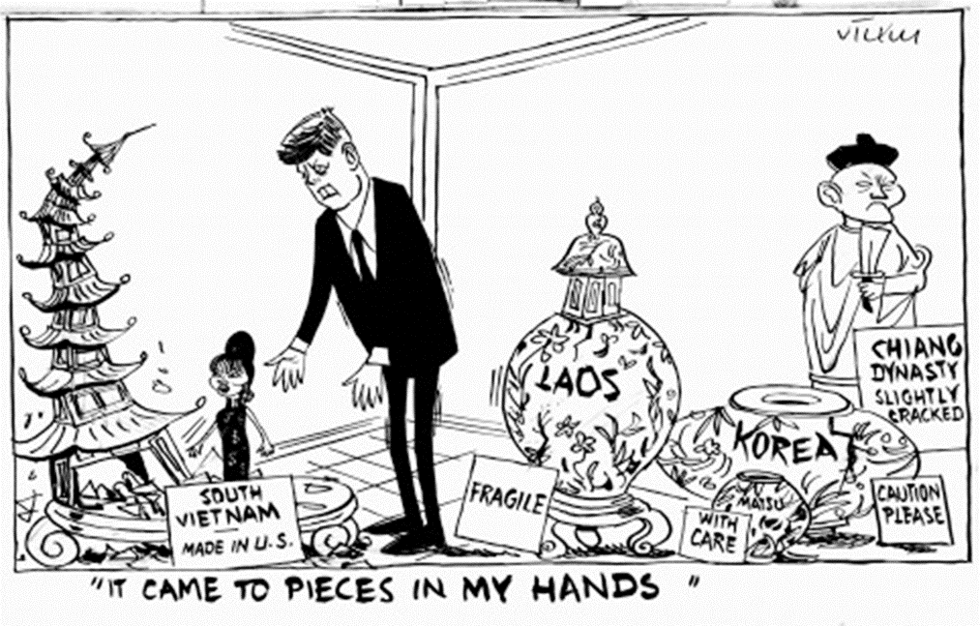
- What is happening with containment? China falls…Korea falls…

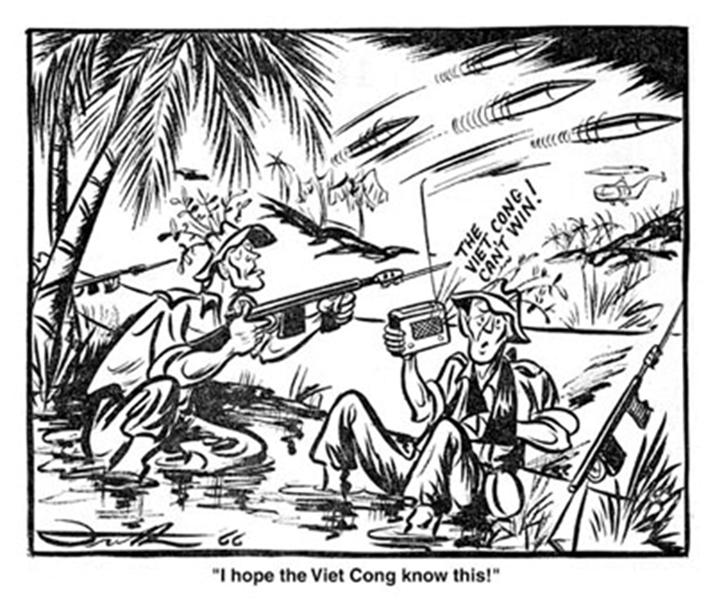
- The US government was saying one thing, but was going on in Vietnam from the soldiers’ point of view?

