(CNN) -- With every passing day, the wait for the kidnapped Nigerian girls gets more agonizing.
Boko Haram seized the nearly 300 schoolgirls and vanished into a dense forest last month. Their abduction sparked a global movement as throngs took to the streets demanding their rescue.
Officials say 276 girls remain missing. Here's why their rescue is a risky, complicated effort.
It's been more than three weeks
The ticking clock could mean the girls are getting farther away.
Militants herded the girls out of bed on April 14 at a school in Chibok in northern Nigeria. A few escaped and shared harrowing tales of fleeing from a nearby forest bordering Cameroon. Relatives roamed through the forest in motorcycles for days, looking for the missing girls. At the time, residents said there were no signs of soldiers searching the area considered a hideout for the militants.
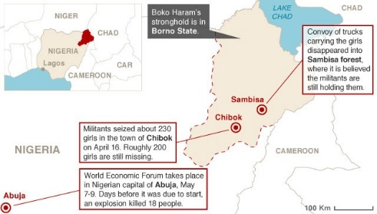Map: Where girls were taken
Victim's family: 'We have nobody to help us'
Malala: 'Girls in Nigeria are my sisters'
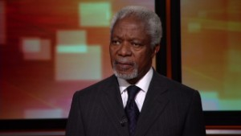Annan: I wish Nigeria action came sooner
The forest borders Cameroon
Local residents say they've heard reports of convoys of cars filled with girls headed to neighboring Cameroon. The borders between the two nations are porous and don't require much to pass through. In some cases, a simple monetary bribe will get you waved into the neighboring nation, in this case a list that includes Chad and Niger.
Location and number of hostages are factors
The girls' abduction occurred in an area where the government doesn't have a firm grip. The school is about 80 miles (130 kilometers) west of Maiduguri and some 600 miles from the capital of Abuja. And the large number of hostages means airstrikes may not be an option because they can kill captives.
A ground assault isn't a great option either -- not when it is done in unfamiliar terrain against entrenched, well-armed fighters.
Nigerian military isn't the most trustworthy
Hours after the girls went missing, the Nigerian military faced criticism for its handling of the kidnapping. It said it had rescued all but eight of the girls, a claim it later recanted after their parents said most remained missing. Ensuing attacks have shown that the security forces don't have the capability to protect civilians, which will make many think twice before providing intelligence.
It's also ill-equipped
Numerous attacks in recent years make it clear that Nigeria does not have the most sophisticated programs to battle terrorism. In addition, it's lacking in intelligence gathering, a crucial element in the search for the missing girls. This has prompted the United States, Britain, China and a host of other nations to step in to fill the gap. The U.S. offer to help includes the creation of a "coordination cell" to provide intelligence, investigations and hostage negotiation expertise, the U.S. State Department said.
Boko Haram beheads negotiators
While negotiations may be an option in some hostage crises, this case may not be so clear cut.
Rights groups have accused Nigeria of using heavy-handed tactics such as illegal searches, torture and extrajudicial killings to crack down on the militants.
As a result, it has eroded trust between the two sides, prompting Boko Haram leader Abubakar Shekau to say he "will not enter a truce with infidels," U.S. lawmakers said last year.
Abducted girls' families search for them
U.S.: No boots on the ground in Nigeria
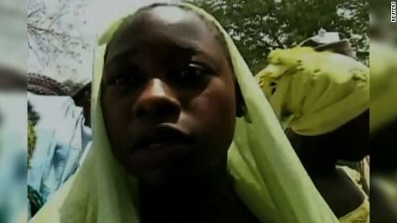Students thought kidnappers were soldiers
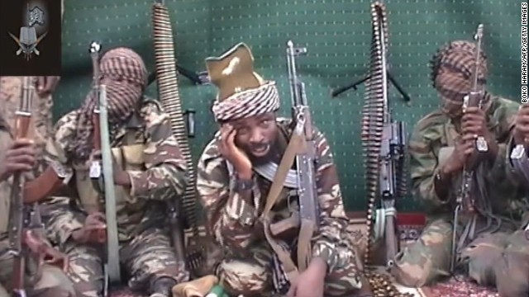Boko Haram: Nigeria's crisis
Boko Haram members who try to negotiate with the government get beheaded.
"Reports of beheadings seem to go up when there are talks of negotiation. It is plausible that many of these beheadings, which rose in frequency in early 2012, are purges of moderate members who have complained or attempted to negotiate," U.S. lawmakers said.
If there are negotiations going on, they have not yielded results so far.
Its members are always on the move
The militants doesn't sit still for long, making them even more elusive. Members hop from one location to another to avoid an intensified government crackdown. They leave their wives behind when they scamper into hideouts deep into forests, forcing the girls and women kidnapped to perform chores and sexual services.
Shekau is a cold, ruthless monster
The Boko Haram leader took credit this week for the Chibok kidnapping. "I abducted your girls," he taunted with a chilling smile. "There is a market for selling humans. Allah says I should sell. He commands me to sell."
He operates in the shadows, leaving his underlings to orchestrate his repulsive mandates. And they have been busy. Days after his video surfaced, details emerged of another abduction of eight girls between ages 12 and 15 on Sunday night in the northeast. And a grisly assault on a local village left at least 150 people dead.
The bounty on his head may not help much
Shekau has been on the U.S. radar since he came to power five years ago. The United States offered a reward of up to $7 million for information leading to his location. But that may not yield immediate results.
"African warlord Joseph Kony's had a bounty for years. Osama bin Laden was not given up because of the $25 million bounty. And who knows whether this will be the case," said Christiane Amanpour, CNN's chief international correspondent.

