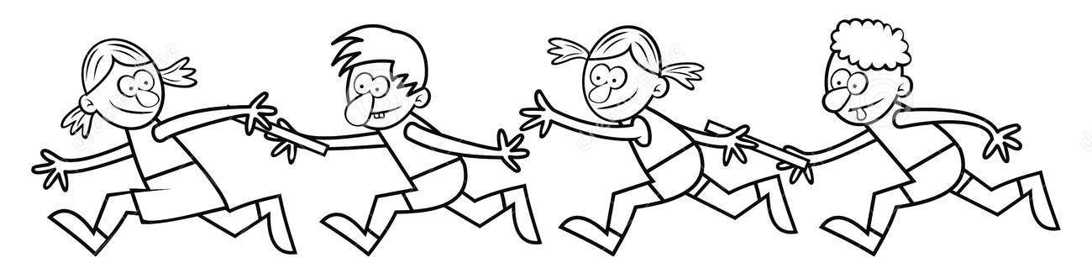
COLLECTIVE LEARNING: Pass It On…

In groups, pretend that there has been a disaster which has killed every human on earth except you and your family (or small group). All books and computers are gone. Fortunately, it didn’t kill any animal or leave any harmful after effects like radiation or giant roaches.
- NO BUILDINGS
- ALL SIGNS OF HUMANITY ARE GONE
- JUST USING THE SKILLS YOU CURRENTLY HAVE

Use a separate piece of paper or the back of the assignment: Each of you have to write down a list of the knowledge and skills you possess that will help you and your family survive.

On chart paper:
List your combined skills

How could you use these skills? LIST

How many things would you be able to maintain? (lights, water, machinery, etc.)

The scenario changes - now there are 1000 people left in the world. How will things change?

Now, imagine that the town library was left behind. How would things potentially change?
