The Crusades Primary Source Analysis
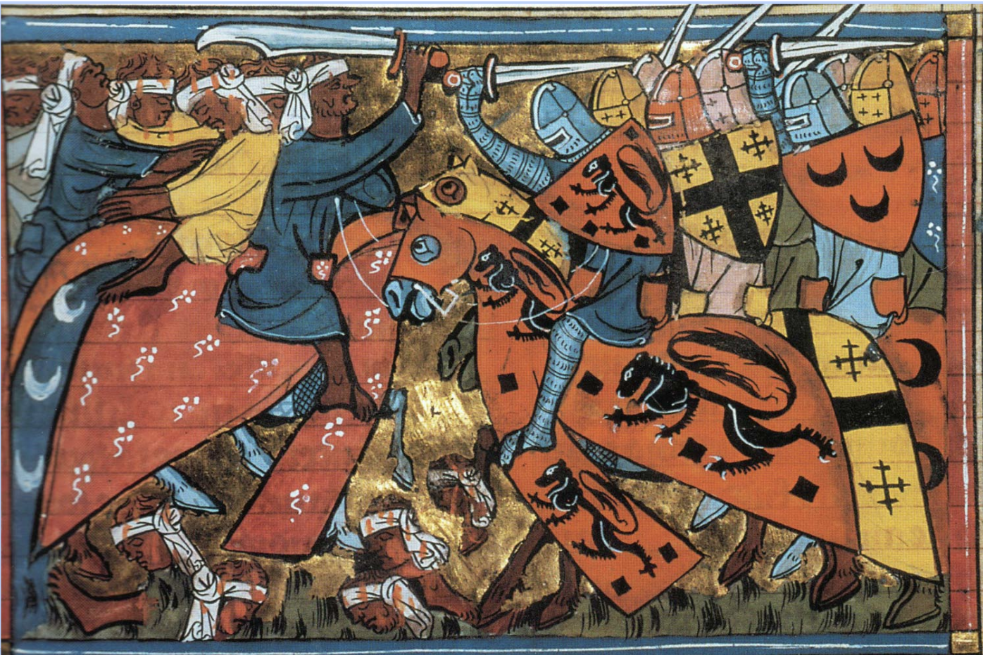

- What do you think is happening in this painting, based on what you know already about religion and world history during this time period?

- What symbols do you notice?

- Who do you think are the people in the painting?

- Who do you think made this painting?

- When do you think this painting was made?

Christian perspective
Fulcher of Chartres
"Although, O sons of God, you have promised more firmly than ever to keep the peace among yourselves and to preserve the rights of the church, there remains still an important work for you to do. . . . For your brethren who live in the east are in urgent need of your help, and you must hasten to give them the aid which has often been promised them. For, as the most of you have heard, the Turks and Arabs have attacked them and have conquered the territory of Romania [the Byzantine Empire]. . . . They have occupied more and more of the lands of those Christians, and have overcome them in seven battles. They have killed and captured many, and have destroyed the churches and devastated the empire. If you permit them to continue thus for awhile with impurity, the faithful of God will be much more widely attacked by them. On this account I, or rather the Lord, beseech you as Christ's heralds to publish this everywhere and to persuade all people of whatever rank, foot-soldiers and knights, poor and rich, to carry aid promptly to those Christians and to destroy that . . . race from the lands of our friends. I say this to those who are present, it is meant also for those who are absent. Moreover, Christ commands it. All who die by the way, whether by land or by sea, or in battle against the [Muslims}, shall have immediate remission of sins. This I grant them through the power of God with which I am invested. . . . "

Muslim Perspective
The Words of Saladin
"If God blesses us by enabling us to drive His enemies out of Jerusalem, how fortunate and happy we would be! For Jerusalem has been controlled by the enemy for ninety-one years, during which time God has received nothing from us here in the way of adoration. At the same time, the zeal of the Muslim rulers to deliver it languished. Time passed, and so did many [in different] generations, while the Franks succeeded in rooting themselves strongly there. Now God has reserved the merit of its recovery for one house, the house of the sons of Ayyub [Saladin's family], in order to unite all hearts in appreciation of its members."

- What is the main idea of the Fulcher of Chartres passage?

- What is the main idea of the Words of Saladin passage?

- In what ways are these sources different?

- What do these two perspectives have in common?

- After reading these, now what do you think the painting means?

