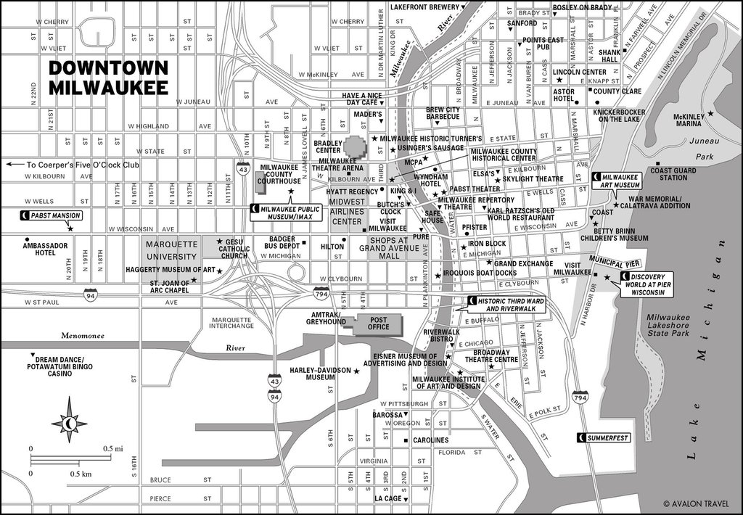
CURRENT MILWAUKEE MAP

