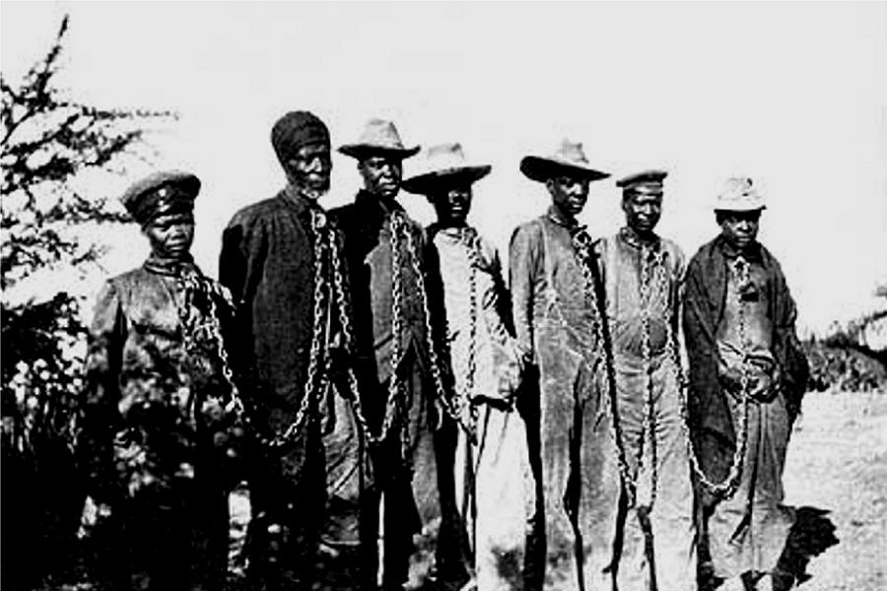
Herero Genocide

The Herero Genocide occurred between 1904-1907 in current day Namibia. The Hereros were herdsmen who migrated to the region in the 17th and 18th centuries. After a German presence was established in the region in the 1800s, the Herero territory was annexed (in 1885) as a part of German South West Africa.
A series of uprisings against German colonialists, from 1904–1907, led to the extermination of approximately four-fifths of the Herero population. After Herero soldiers attacked German farmers, German troops implemented a policy to eliminate all Hereros from the region, including women and children.

The Armenian Genocide
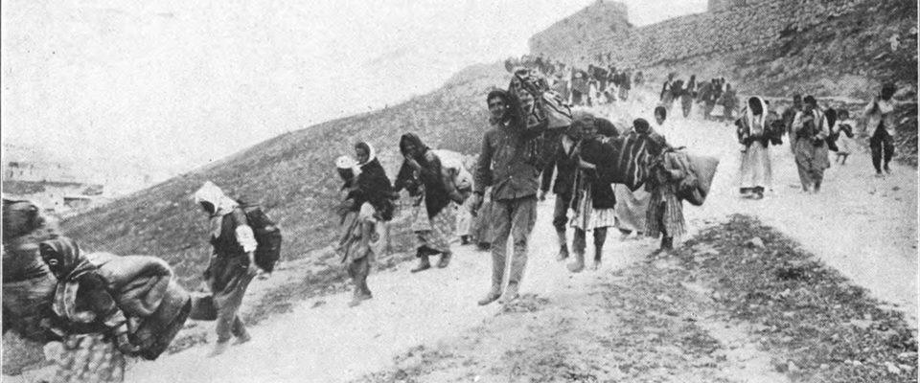

The Armenian Genocide was carried out by the "Young Turk" government of the Ottoman Empire from 1915 to 1923. Starting in April 1915, Armenians in the Ottoman armies, serving separately in unarmed labor battalions, were removed and murdered. Of the remaining population, the adult and teenage males were separated from the deportation caravans and killed under the direction of Young Turk functionaries.
Women and children were driven for months over mountains and desert, often raped, tortured, and mutilated. Deprived of food and water, they fell by the hundreds of thousands along the routes to the desert. Ultimately, more than half the Armenian population (1,500,000 people) was annihilated. Pontic Greeks and the Assyrians were also targeted by the Ottoman Turks.

The Ukrainian Genocide/The Great Famine
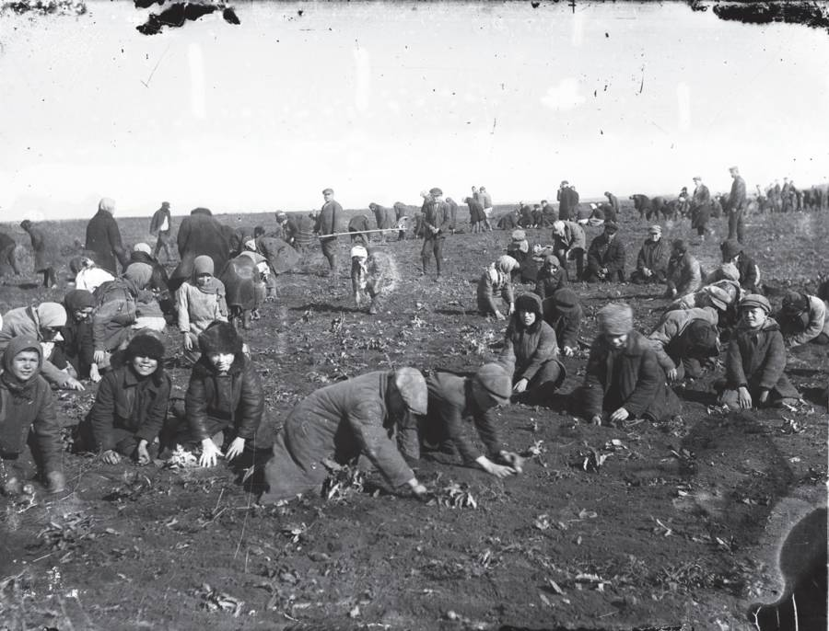
In 1932-33, Joseph Stalin, leader of the Soviet Union, imposed the system of land management know as collectivization. This resulted in the seizure of all privately owned farmland and livestock. By 1932, much of the wheat crop was dumped on the foreign market to generate cash to aid Stalin’s Five-Year Plan.
The law demanded that no grain could be given to feed the peasants until a quota was met. By the spring of 1933, an estimated 25,000 people died every day in the Ukraine. Deprived of the food they had grown with their own hands, an estimated 7,000,000 persons perished due to the resulting famine in this area known as the breadbasket of Europe.

Rape of Nanking
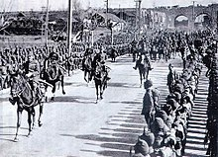
In December of 1937, the Japanese Imperial Army marched into China’s capital city of Nanking and proceeded to murder 300,000 out of the 600,000 civilians and soldiers in the city. After just four days of fighting, Japanese troops smashed into the city with orders issued to “kill all captives.”
The terrible violence - citywide burnings, stabbings, drownings, rapes, and thefts - did not cease for about six weeks. It is for the crimes against the women of Nanking that this tragedy is most notorious. The Japanese troops raped over 20,000 women, most of whom were murdered thereafter so they could never bear witness.

The Holocaust
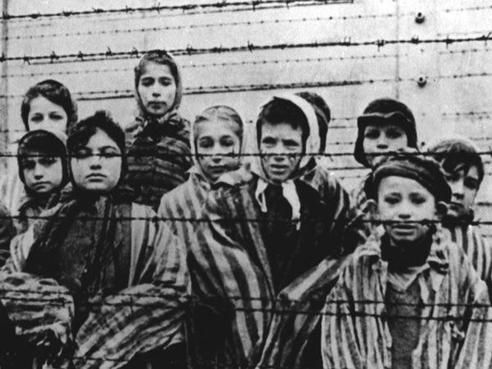
In 1933, the Jewish population of Europe stood at over nine million. 1945, close to two out of every three European Jews had been killed as part of the "Final Solution", the Nazi policy to murder the Jews of Europe. At least 200,000 mentally or physically disabled people were murdered in the Euthanasia Program. More than three million Soviet prisoners of war were murdered or died of starvation, disease, neglect, or maltreatment. The Germans targeted the non-Jewish Polish intelligentsia for killing, and deported millions of Polish and Soviet citizens for forced labor in Germany or in occupied Poland. From the earliest years of the Nazi regime, homosexuals and others deemed to be behaving in a socially unacceptable way were persecuted.
Thousands of political dissidents (including Communists, Socialists, and trade unionists) and religious dissidents (such as Jehovah's Witnesses) were also targeted. Many of these individuals died as a result of incarceration and maltreatment.
Mao’s Cultural Revolution
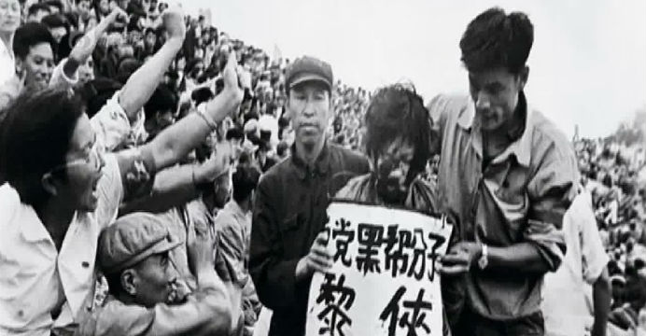
October 1, 1949 marked Mao Tse-tung’s proclamation of the People’s Republic of China. The Chinese Communist Party launched numerous movements to systematically destroy the traditional Chinese social and political system. One of Mao’s major goals was the total collectivization of the peasants. In 1958, he launched the “Great Leap Forward” campaign.
This act was aimed at accomplishing economic and technical development of the country at a faster pace and with greater results. Instead, the “Great Leap Forward” destroyed the agricultural system, causing a terrible famine in which 27 million people starved to death.

The Killing Fields: The Cambodian Genocide
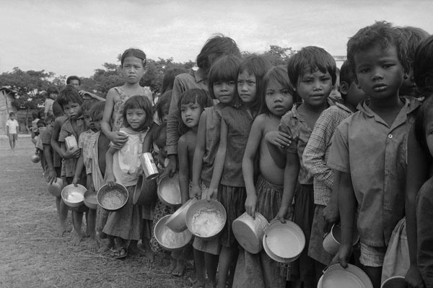
From 1975-1979, Pol Pot led the Khmer Rouge political party in a reign of violence, fear, and brutality over Cambodia. An attempt to form a Communist peasant farming society resulted in the deaths of 25% of the population from starvation, overwork, and executions.
By 1975, the U.S. had withdrawn its troops from Vietnam, and Cambodia lost its American military support. Taking advantage of this opportunity, Pol Pot’s Khmer Rouge seized control of Cambodia. Inspired by Mao’s Cultural Revolution in Communist China, Pol Pot attempted to “purify” Cambodia of western culture, city life, and religion. Different ethnic groups and all those considered to be of the “old society”, intellectuals, former government officials, and Buddhist monks were murdered. “What is rotten must be removed” was a slogan proclaimed throughout the Khmer Rouge era.
Bosnia and Herzegovina
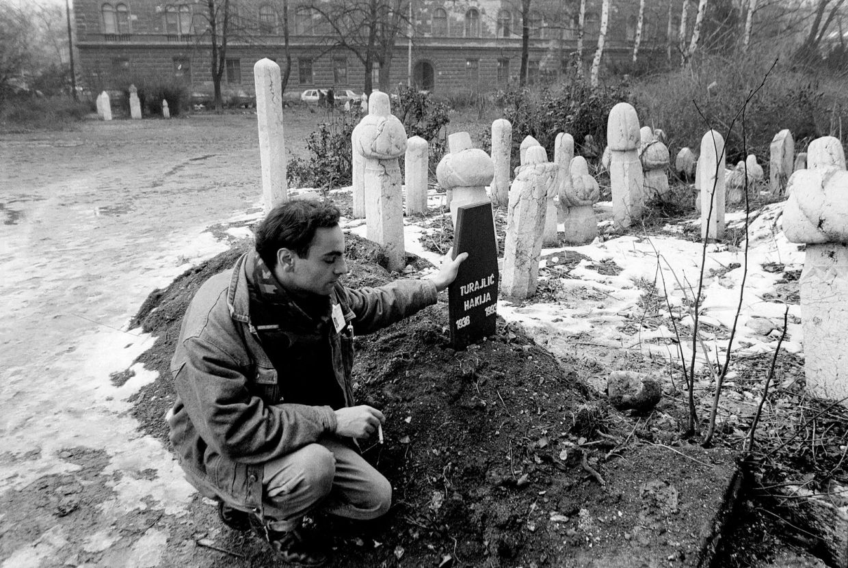
In the republic of Bosnia-Herzegovina, conflict between the three main ethnic groups - the Serbs, Croats, and Muslims - resulted in genocide committed by the Serbs against Bosnian Muslims. In the late 1980’s a Serbian named Slobodan Milosevic came to power. In 1992 acts of “ethnic cleansing” started in Bosnia, a mostly Muslim country where the Serb minority made up only 32% of the population.
Milosevic responded to Bosnia’s declaration of independence by attacking Sarajevo, where Serb snipers shot down civilians. They systematically rounded up local Muslims and committed acts of mass murder, deported men and boys to concentration camps, and forced repopulation of entire towns. Serbs also terrorized Muslim families by using rape as a weapon against women and girls. Over 200,000 Muslim civilians were systematically murdered and 2,000,000 became refugees at the hands of the Serbs.
Rwandan Genocide
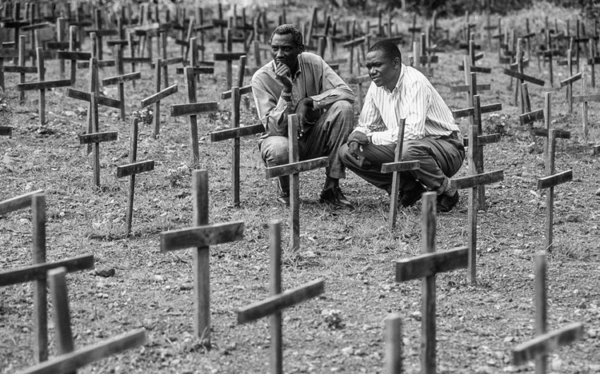
Beginning on April 6, 1994, groups of ethnic Hutu, armed mostly with machetes, began a campaign of terror and bloodshed which embroiled the Central African country of Rwanda. For about 100 days, the Hutu militias, known in Rwanda as Interhamwe, followed what evidence suggests was a clear and premeditated attempt to exterminate the country's ethnic Tutsi population. The Rwandan state radio, controlled by Hutu extremists, further encouraged the killings by broadcasting non-stop hate propaganda and even pinpointed the locations of Tutsis in hiding. The killings only ended after armed Tutsi rebels, invading from neighboring countries, managed to defeat the Hutus and halt the genocide in July 1994. By then, over one-tenth of the population, an estimated 800,000 persons, had been killed. The country's industrial infrastructure had been destroyed and much of its population had been dislocated.

Darfur
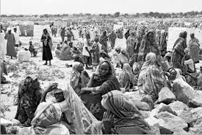
Violence and destruction are raging in the Darfur region of western Sudan. Since February 2003, government-sponsored militias known as the Janjaweed have conducted a calculated campaign of slaughter, rape, starvation and displacement in Darfur, mainly targeted against three tribes (Fur, Masalit, and Zaghawa).
It is estimated that 400,000 people have died due to violence, starvation and disease. More than 2.5 million people have been displaced from their homes and over 200,000 have fled across the border to Chad. Many now live in camps lacking adequate food, shelter, sanitation, and health care.
The United States Congress and President George W. Bush recognized the situation in Darfur as "genocide." Darfur, "near Hell on Earth," has been declared the worst humanitarian crisis in the world today.

