Stay a while on the Nile Travel
Free Embalming URN with Purchase!
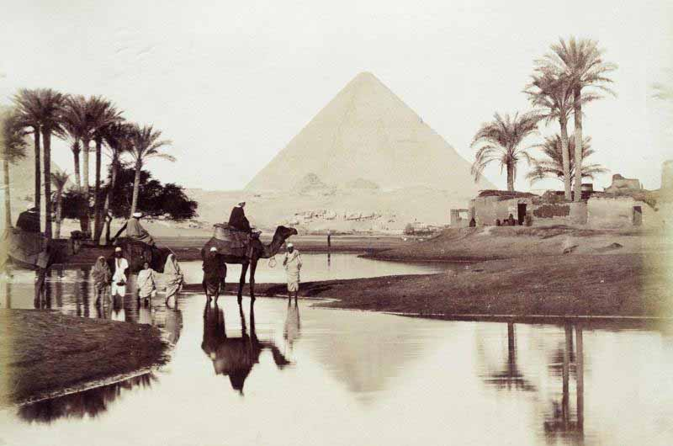

You are a travel guide during 2000 BCE. You are going to plan the most thorough, exciting, and educational trip your ancient visitor could possibly imagine! Your client needs to know as much as possible about your civilization in order to truly enjoy themselves, take advantage of all your civilization has to offer, AND stay out of trouble! What are you going to do? Where are you going to go? How do you need to act? Who are you going to meet? I HAVE NEVER BEEN THERE… DESCRIBE IT TO ME. SELL ME ON COMING WITH YOU!

You will be working INDEPENDENTLY on this project. You are researching an assigned civilization. You will organize your research into a google slideshow that you will share with me and presenting to the class. See the attached rubric for the requirements. Use the outline below to organize and guide your notes while you are researching your civilization. Use credible websites. No Wiki...Use websites from the East LMC site. College/university sites are reliable.

THIS IS 90 POINTS

YOUR CIVILIZATION _____________________________________

PART 1:
DO YOUR RESEARCH USING THE OUTLINE (OK to use seperate pieces of paper) You will be turning in your research notes as part of your assignment:
- PHYSICAL TRAITS of your civilization
  - WHERE

  - WHAT does the land look like (if there is more than 1 type of environment, describe it)

  - CLIMATE: describe the weather and the seasons
  - HOW would it have looked AT THE TIME OF YOUR CIVILIZATION: houses, buildings, farms, temples, monuments. What were the built out of? Architecture?

  - HOW was it LAID OUT (city planning, who lived where)

- WHEN did your society exist

- DESCRIBE your CULTURE
  - SOCIAL STRUCTURE
    - Roles of men and women

    - Classes/who does what

    - jobs/positions

  - RELIGIOUS BELIEFS and PRACTICES
    - Ceremonies (describe)

    - Gods/goddesses (different ones for different things?)

    - Role of gods and beliefs in life

    - Role of the religious leaders (priests, priestesses, healers)

  - POLITICAL STRUCTURE
    - Who is is the ruler

    - How did he/she become the leader

    - What are some laws of the land

    - How are laws enforced and what are punishments for breaking them

  - ECONOMICS
    - What things does your civilization produce for trade (manufacture/technology)

    - Who do they trade with

  - PEOPLE
    - Describe clothing (different for different classes) of the TIME

    - Crops they grew
    - What kind of animals would they have raised

    - Food

    - Language
      - Spoken

      - Written (who would have known how to read and write)

    - Transportation (how did they get around (types of animals, etc.)

- WHAT HAPPENED to your civilization? WHY ISN’T it still around?
  - When did it fall

  - Why did it fall - what happened?

- What is it like TODAY (2018)
  - Who lives there (in the same area)

  - What do they produce

  - What is their culture like

  - What is their government like
PART 2
When you are DONE doing your research you are going to organize it into a slide presentation. You will design it as a TOUR PRESENTATION that you are giving to ANCIENT PEOPLE who are traveling to YOUR ANCIENT CIVILIZATION. Keep in the time. You will be writing about the PAST as if you are there (present tense). You are GIVING ADVICE. You are not delivering a research report. It should be EXCITING. 12 Slides MINIMUM. Pictures, maps, and creativity is EXPECTED.

SLIDESHOW REQUIREMENTS
- Title slide: introduce your agency and where we are going and when
- How am I going to get to your civilization (what forms of transportation do you have)
- Where are you located? MAPS - 1. World map to show where in the world it is and 2. What the area looks like
- What should I pack?
  - Describe the CLIMATE/SEASON.
  - What is the weather like at different times of year
  - What is the land like? (forests, swamps, desert, rivers, etc.)
  - What kind of clothing do they wear there - I want to fit in and be comfortable! (NO MODERN CLOTHING!!!!!!)
- What are we going to see?
  - Landmarks/important buildings
  - Where people live
- What are the people like - how can I fit in and not offend anyone?
  - What can I expect to see men and women doing differently
  - What are the social classes and what do they do
  - Who is the leader? Who else is important?
  - What are some laws are should be careful of?
  - What happens if I break a law?
  - What language do you speak?
  - What might I do for fun?
- What religious things will I see?
  - Describe ceremonies
  - Practices and beliefs (gods, etc.) and the priest/priestess
- What kind of things can I buy or find in the marketplace?
  - What goods do you produce?
  - Who do you trade with?
  - What kind of technology do you have (because I may want to take it back to my home to use, too!)
- What am I going to eat?
  - Crops and animals you raise
  - What might I use to eat out of (think about artifacts that were found)

LAST SLIDES: NOT IN THE TIME PERIOD! THEY ARE PRESENT DAY
- What happened to your civilization?
  - When did it fall
  - What happened
  - Did someone else take over? Who?
- Describe what it is like TODAY (2018)
  - People who live there and their culture
  - Important places
  - Political system/leader
  - Economy
- Why is this civilization important? What did it contribute to society today??
- BIBLIOGRAPHY - use easybib or bibme and attach it to the slide OR share with me. THIS IS A PART OF YOUR GRADE!

Graded items | 0-1.9 Incomplete, min, inaccurate, errors | 2-2.9 basic, complete, w/o details, inacc, errors | 3-3.9 accur, relevant, creative, min errors | 4-5 extra, detailed, no errors
RESEARCH NOTES
x 1.5
BIBLIOGRAPHY x1.5
CONTENT:
TRANSPORTATION x1
CONTENT: MAPS & LOCATION x1
CONTENT: CLIMATE/ CLOTHING x1
CONTENT: LANDMARKS/ BUILDINGS x1
CONTENT:PEOPLE: SOCIAL ROLES, LEADER, LAWS, LANGUAGE x1
CONTENT: RELIGIOUS BELIEFS & PRACTICES x1
CONTENT: TRADE/ ECONOMY x1
CONTENT: FOOD, CROPS x1
CONTENT: WHAT HAPPENED TO YOUR CIVILIZATION x1
CONTENT: WHAT IS IT LIKE TODAY x1
CONTENT: CONTRIBUTIONS TO TODAY
PERSPECTIVE: IN THE TIME PERIOD OF THE ANCIENT CIVILIZATION x1
MECHANICS: GRAMMAR, SPELLING, ORGANIZATION x1.5
CREATIVITY: PICTURES, ADDITIONAL MAPS x1.5

