EASTERN HEMISPHERE:
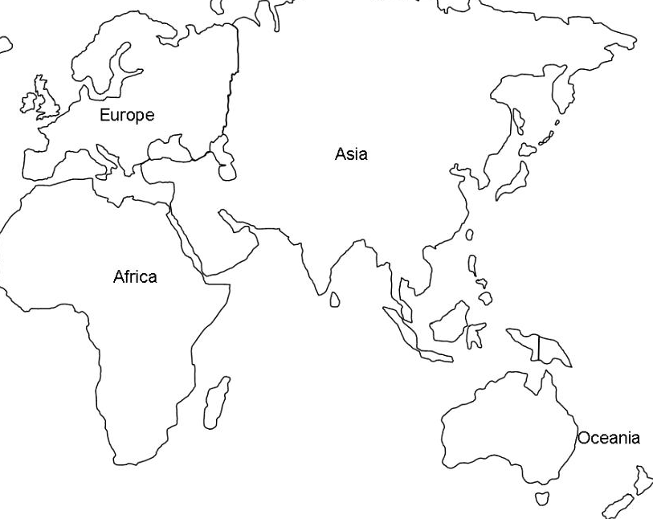
- Label and Mark the following locations:
Cairo (Egypt) Mecca (Saudi Arabia) Aden (Saudi Arabia) Abyssinia (Ethiopia)
Kilwa (Tanzania) Gujarat (Indian Region) Goa (India) Ceylon (Sri Lanka)
Malacca
- Plot trade routes to Malacca from these locations on your map with different colored markers/pencils
- Label the following:
Malaysia (country – outline current day borders) Cambodia (country – outline current day borders)
Indian Ocean Pacific Ocean South China Sea Arabian Sea
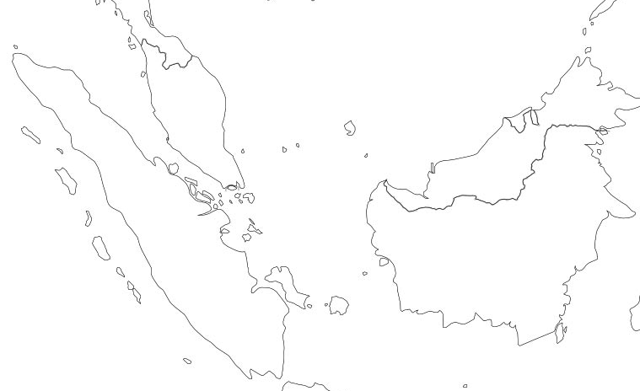

PORT OF MALACCA

- Label and Mark the following locations:
Strait of Malacca Indian Ocean Java Sea South China Sea

