MIDDLE PASSAGE DOCUMENT ANALYSIS

Document A:

The development of the slave trade became part of the process of settling the American continent. In comparison with Indian slavery, the blacks had a better physical capacity and resisted better to the climate, two important factors to justify the successive waves of slaves that left Africa towards America. The time between the moment the slaves were bought and when they arrived at port was very dangerous not only for the European traders but for the slaves as well. Revolts and disturbances occurred frequently. Crossing the Atlantic was extremely difficult for slaves. First there was not enough room in the boats. They suffered from heat, thirst, and a lack of hygiene. Even the whites had difficulty with these things. At the time the European states did not recognize the negative consequences of these massive migrations. On the other hand, a new diverse cultural situation originated on the American continent that resulted from the multiplicity of mixed races and cultures. Brazil became the most expressive model of the process carried out by the Portuguese as it melted Indian, white, and black in a complex mix of ethnicities and cultures.

Vocabulary:
hygiene: cleanliness
expressive: effectively conveying an idea

Document B:

There happened such sickening and mortality among my poor men and Negroes. Of the first we buried 14, and of the last 320, which was a great detriment to our voyage, the Royal African Company losing ten pounds by every slave that died. . . . The distemper which my men as well as the blacks mostly died of was the white flux. . . . The Negroes are so vulnerable to the small-pox that few ships that carry them escape without it, and sometimes it makes vast havoc and destruction among them. But though we had 100 at a time sick of it . . . we lost not above a dozen by it. . . . But what the smallpox spared, the flux swept off, to our great regret, after all our pains and care to give [the slaves] their messes, . . . keeping their lodgings as clean and sweet as possible, and enduring so much misery and stench so long among creatures nastier than swine, only to be defeated by their mortality. . . . No gold-finders can endure so much noisome slavery as they do who carry Negroes. . . . We endure twice the misery; and yet by their mortality our voyages are ruined.

Vocabulary:
mortality: death, especially on a large scale
distemper: disorder or disease
white flux: intestinal infection that caused intense diarrhea
messes: meals
swine: pigs
gold-finders: individuals seeking wealth
noisome: unpleasant

Document C:

The men negroes, on being brought aboard the ship, are immediately fastened together, two and two, by hand-cuffs on their wrists, and by irons riveted on their legs. They are then sent down between the decks. . . . They are frequently stowed so close, they can only lie on their sides. . . . In each of the apartments are placed three or four large buckets [for human waste]. . . . It often happens, that those who are placed at a distance from the buckets . . . tumble over their companions because they are shackled. . . . In this distressed situation . . . they give up and relieve themselves as they lie. . . . Their food is served up to them in tubs, about the size of a small water bucket. They are placed around these tubs in companies of ten . . . If negroes refused to take sustenance, I have seen coals of fire, glowing hot, put on a shovel, and placed so near their lips, as to scorch and burn them. . . . The hardships and inconveniences suffered by the negroes during the passage, are hard to describe. . . . The exclusion of the fresh air is among the least tolerable. . . . The floor of their rooms was so covered with blood and mucus because of the flux, that it resembled a slaughter-house. It is not in the power of the human imagination to picture to itself a situation more dreadful or disgusting. The surgeons employed in the Guinea trade, are generally driven to engage in so disagreeable a job by their financial situations.

Vocabulary:
riveted: metal bolted together
flux: intestinal infection that caused intense diarrhea
stowed: put in a particular place
shackled: chained
Guinea trade: slave trade
take sustenance: eat

Document D:

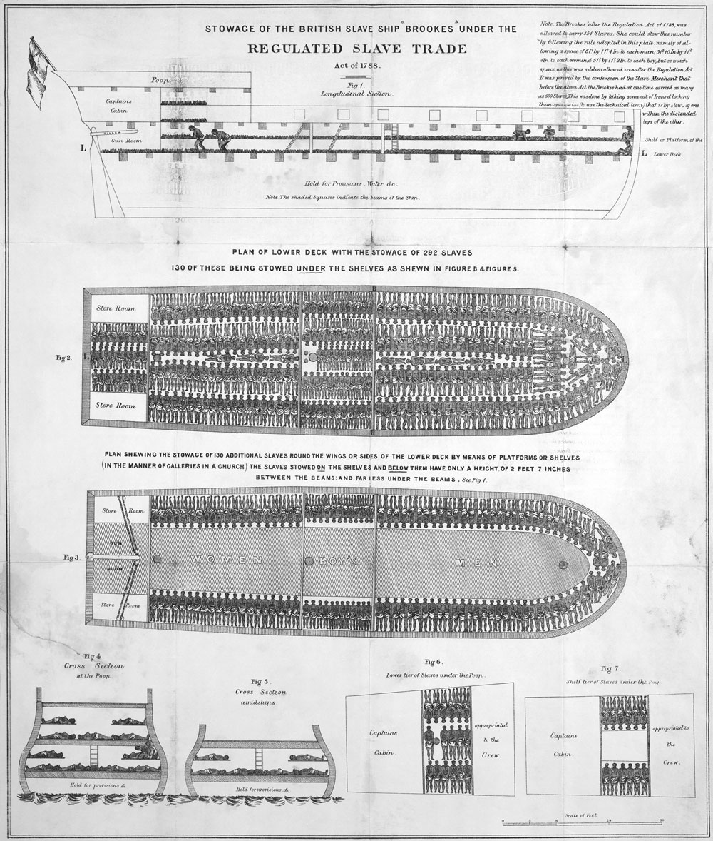

Document E:

I was soon put down under the decks, and there I received such a smell in my nostrils as I had never experienced in my life: so that, with the loathsomeness of the stench, and crying together, I became so sick and low that I was not able to eat, nor had I the least desire to taste anything. I now wished for the last friend, death, to relieve me; but soon, to my grief, two of the white men offered me food; and, on my refusing to eat, one of them held me fast by the hands, and laid me across I think the windlass, and tied my feet, while the other flogged me severely. I had never experienced anything of this kind before. . . . The crew used to watch us very closely who were not chained down to the decks, in case we would leap into the water: and I have seen some of these poor African prisoners most severely cut for attempting to do so, and hourly whipped for not eating. This indeed was often the case with myself. . . I feared I should be put to death, the white people looked and acted, as I thought, in so savage a manner; for I had never seen among any people such instances of brutal cruelty; and this not only shown towards us blacks, but also to some of the whites themselves. One white man in particular I saw, when we were permitted to be on deck, flogged so unmercifully with a large rope near the foremast, that he died . . . and they tossed him over the side. . . This made me fear these people the more.

Vocabulary:
loathsomeness: unpleasantness
windlass: machine used to raise the anchor
flogged: whipped

MATCH THE DOCUMENTS TO THE SOURCES. WRITE THE DOCUMENT # BY THE CORRECT SOURCE

____________Autobiography of a Former Slave (Modified): Olaudah Equiano, The Interesting Narrative of the Life of Olaudah Equiano, Or Gustavus Vassa, the African, 1789.
Olaudah Equiano was born in West Africa. As a young boy, he was kidnapped by an African tribe and sold to European slave traders, who took him to Virginia. He eventually purchased his freedom and moved to England, where he became active in the abolition movement. He later wrote an autobiography describing his experiences as a slave. Recently, a historian located evidence indicating that Equiano was actually born in South Carolina. However, other historians maintain that there is strong evidence corroborating Equiano’s account. Moreover, this is one of the only accounts of the Middle passage from the perspective of a slave. These are excerpts from Equiano’s autobiography.

___________Slave Ship Doctor (Modified): Alexander Falconbridge, An Account of the Slave Trade on the Coast of Africa, 1788.
Alexander Falconbridge served as a doctor (known as the surgeon on ships) on British slave ships during the 1780s. He later wrote a book, An Account of the Slave Trade on the Coast of Africa, about his experiences. The book became popular among abolitionists and he later worked with the Anti-Slavery Society. These are excerpts from his book.

___________Portuguese Textbook (Modified): History for Grade Ten, Volume 2, published in Portugal in 1994.
Portugal was one of the first European countries to engage in the African slave trade. Portuguese ships played a key role in the slave trade between Europe, Africa, and the Americas for several centuries. The following excerpt comes from a Portuguese high school textbook.

___________Slave Ship Diagram: “Stowage of the slave ship ‘Brookes’ under the Regulated Slave Trade Act of 1788.”
This is part of a diagram depicting the British slave ship Brookes after the passage of the Regulated Slave Trade Act of 1788. This law, which sought to improve conditions on slave ships, was passed in response to rising opposition to the slave trade in England. This document depicts how many slaves could be placed on this ship. With 6’ by 1’4” allowed for each man, 5’10” by 1’4” allowed for each woman, and 5’ by 1’2” allowed for each boy, the ship could hold 454 slaves. Before Britain began regulating the slave trade, the ship reportedly carried as many as 609 slaves.

___________Slave Ship Captain (Modified): Thomas Phillips, A Collection of Voyages and Travels, 1732.
Captain Thomas Phillips transported slaves from Africa to Barbados on the ship Hannibal in 1693. The ship left the African island of São Tomé on August 25th and arrived in Barbados on November 4th.The Royal African Company of London funded the trip. This is an excerpt from his journal about the voyage.

