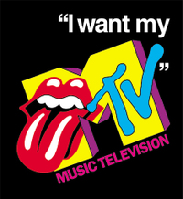

Watching the video, what do you think the ‘80s were like? Briefly describe what you see and what you think it was like to be your age in the 1980s.

If someone was to watch or listen to your music in the future, what would they think 2014 was like? Describe what the music sounds like, musicians look like and mood of it.

CHOOSE 1 of these:
- Write your own lyrics reflecting the 2010s

- Answer: How did MTV change culture?

- Reflect on how music impacts your own culture. How do you dress, act, etc. that is influenced by what you listen to and musical acts you watch?

