Peace in the Middle East DBQ = 60 pts

Essential Question: Why has there not been peace between Israel and Palestine?

- Must refer to the history of the conflict
- Describe the flaws with solutions

- You MUST use 4 documents minimum
  - Must INCLUDE at least ONE of the following:
    - Israeli Declaration of Independence
    - Palestinian National Charter
- Use the Background Article (does not count as one of the 4 documents)

Paper should be a minimum of 5 paragraphs and 2 pages TYPED.

CITE your evidence (“according to Document 1” or “Max Fisher in the background article…” or the Balfour Declaration states…” in your writing.

Writing guidelines:

- Write ONLY in third person. NO “I” or “you” statements.
- Absolutely no obvious statements such as:
  - No “In my opinion”... Or “as I said… “
  - No “In conclusion..” or “To summarize…” or anything similar.
  - No “I’m about to tell you…”
- Use ACADEMIC LANGUAGE and terms from class when possible
Thesis is a statement with an overview of your argument.
Do NOT list your arguments:
- First…. Secondly…. Third…
Conclusion:
- This is NOT just re-stating your introduction and thesis.
- No “In conclusion…”, etc.
- The conclusion answers “so what?” Why does studying this topic matter? No peace in the middle east means what to the world?

**** YOUR OUTLINE IS REQUIRED AND PART OF YOUR GRADE ****

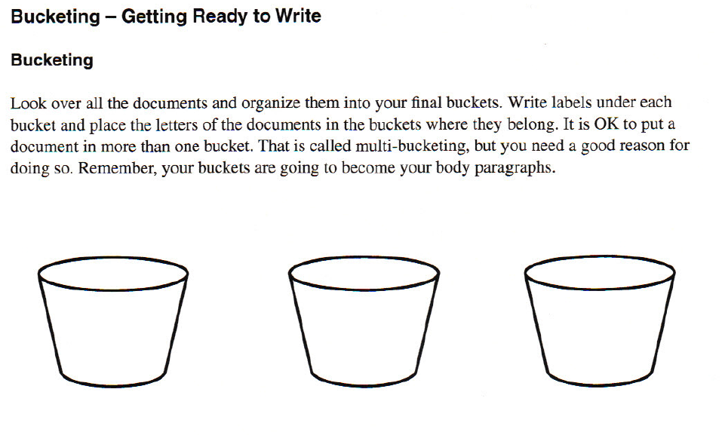
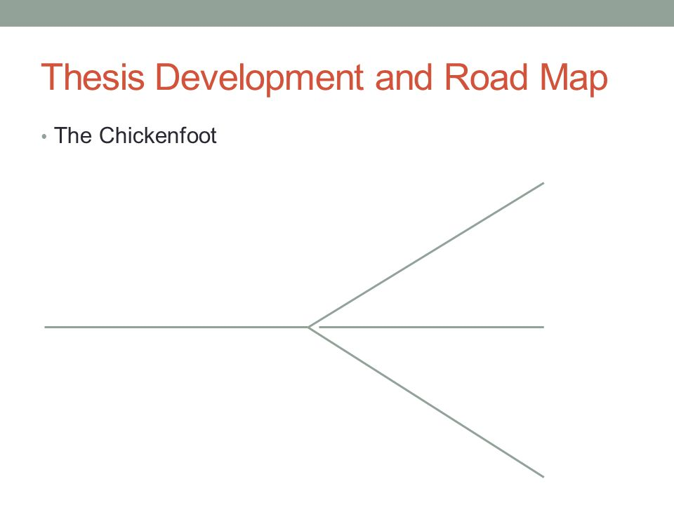

Thesis Statement (major argument you are making from the documents):

Background about the conflict:

Evidence 1: Document -
What is it and what does it say?

How does it support the argument?

Evidence 2: Document -
What is it and what does it say?

How does it support the argument?

Evidence 3: Document -
What is it and what does it say?

How does it support the argument?

Conclusion:
Why does this matter?

What does the future look like for this conflict?

