Segregation in Milwaukee Slides Packet

- What is “white flight”? Why does it happen?

2. VEL PHILLIPS VIDEO QUESTIONS:

After viewing the Alderwoman Vel Phillips video (http://wihist.org/1yqyrmB) answer the following questions (part of the transcript is below)

At 1:25, Alderman Robert Dwyer responds by proposing that her ordinance be left to committee. He objects to what he terms her “veiled threat” and questions the motives of the demonstrators.
At 3:25, Phillips summarizes the national importance of the Milwaukee fair housing struggle and urges that the ordinance not be held up in the city attorney’s office “until things simmer down, because things are not going to simmer down.”

- The opening speaker is Alderwoman Vel Phillips. What is her main point?

- How would you describe her demeanor and behavior toward the other council members she’s addressing?

- At 1:25, Dwyer replies to Phillips. What are his main points?

- How would you describe Dwyer’s demeanor and behavior toward Phillips?

- Phillips was the only woman and the only African American on the Common Council. Imagine that you are in her position. Smartphones didn’t exist back then, but imagine that they did. Compose 3 Tweets or text messages during the meeting about what is happening. The audience who will read them includes the Commandos who stand and clap and other supporters.

- What surprised you in this video?

- What did you realize or learn for the first time when watching it? (“Nothing” will be marked wrong)

3. FAIR HOUSING LAW:

In April 1968, six months after the events depicted in the Vel Phillips video, the US Government passed a law prohibiting discrimination in housing. The Milwaukee Common Council followed suit.

Read the excerpt from the Fair Housing law (Title VIII of the Civil Rights Act of 1968)

Sec. 804. [42 U.S.C. 3604] Discrimination in sale or rental of housing and other prohibited practices As made applicable by section 803 of this title and except as exempted by sections 803(b) and 807 of this title, it shall be unlawful--
(a) To refuse to sell or rent after the making of a bona fide offer, or to refuse to negotiate for the sale or rental of, or otherwise make unavailable or deny, a dwelling to any person because of race, color, religion, sex, familial status, or national origin.

(b) To discriminate against any person in the terms, conditions, or privileges of sale or rental of a dwelling, or in the provision of services or facilities in connection therewith, because of race, color, religion, sex, familial status, or national origin.

(c) To make, print, or publish, or cause to be made, printed, or published any notice, statement, or advertisement, with respect to the sale or rental of a dwelling that indicates any preference, limitation, or discrimination based on race, color, religion, sex, handicap, familial status, or national origin, or an intention to make any such preference, limitation, or discrimination.
(d) To represent to any person because of race, color, religion, sex, handicap, familial status, or national origin that any dwelling is not available for inspection, sale, or rental when such dwelling is in fact so available.

(e) For profit, to induce or attempt to induce any person to sell or rent any dwelling by representations regarding the entry or prospective entry into the neighborhood of a person or persons of a particular race, color, religion, sex, handicap, familial status, or national origin.

Answer the following questions WITH A PARTNER

- What’s the most important phrase in the opening four lines?

B. Choose two of the sections (a through e) and rewrite them in simpler, shorter ways that somebody younger than you could understand.

C. Debate with your partner: Should people be able to live wherever they want, if they can afford it? WHY?

D. Should landlords be able to reject anybody they want, for any reasons they want? WHY?

E. Do these 2 ideas conflict? How could your resolve any conflict you see?

F. Think about your school, your neighborhood, and your community. Do you see people from lots of different racial and ethnic backgrounds?

List 2 advantages racially diverse community:

List 2 struggles of diverse communities:

4. PROTEST MARCH VIDEO:

On August 29, 1967, 250 protesters led by Father James Groppi marched across the 16th Street Bridge toward a park on the south side to protest segregation and demand fair housing law. They were met by 13,000 white residents carrying clubs, hurling glass bottles, and shouting racial slurs and proganities. This video from that night has no sound track. Watch it and answer the following questions:

- List the different types of people you seen in the first 30 seconds

- Where do you think they are?

- What is happening?

- Look closely at the people shown between the 15-30 second marks. What do you think they are saying, based on their actions and facial features?

- From what you can see in the video, did the police act properly or improperly? Why do you say that? Explain.

- Imagine you are one of the marchers in the video. Write Tweets or text messages to your friends about what is happening to you. Write one from each scene in the video and assume they are happening a few minutes apart.

5. DEMOGRAPHIC MAPS of MILWAUKEE:

View the maps below and answer the questions attached to them.

Description of the 1st map:

Restrictive Covenants:
Mr. George Brawley, a Milwaukee attorney, has recently completed a study of the race restrictive covenants contained in plats filed with the Register of Deeds office of Milwaukee County. He estimates that 90% of subdivisions which have been platted in the City of Milwaukee since 1910 contain some type of covenant which has the effect of prohibiting the sale of the property to Negroes.
He states that in other parts of the city there are “gentlemen’s agreements” not to sell or rent property to Negroes except within the area bounded by W. North, W Juneau, N. 3rd, and N. 12th Streets.
Race
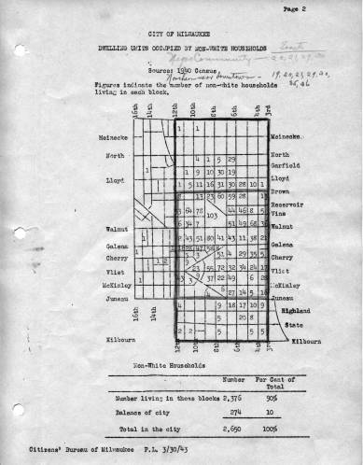
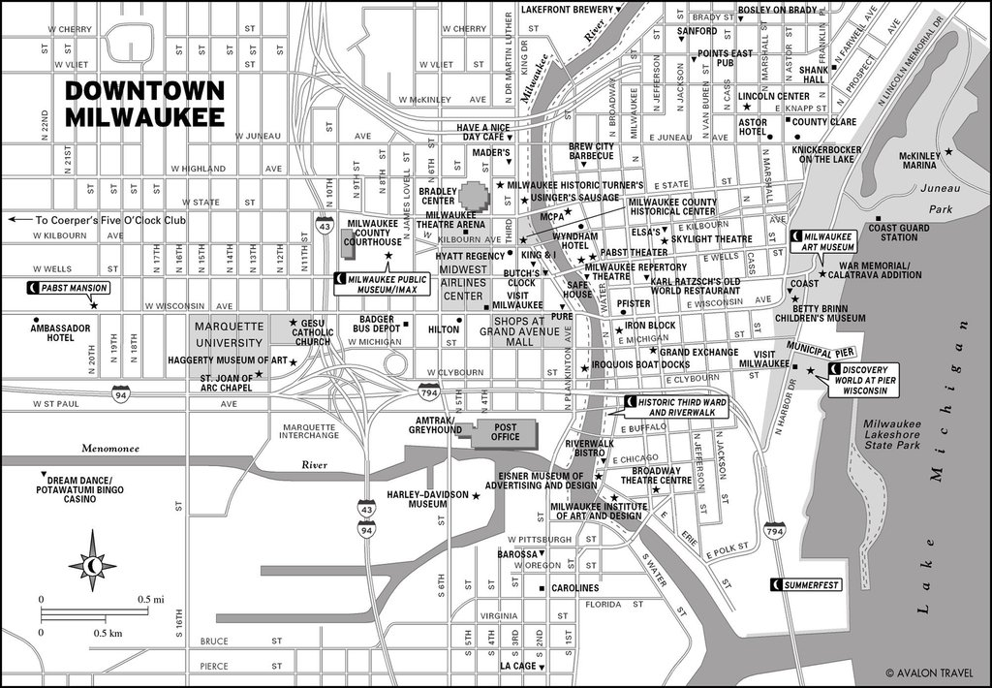

- Look closely at the maps. Can you find where I-94 is on BOTH maps? Marquette University? The Bradley Center?

- What happens to the people living here when a highway is expanded or a museum is built?

- What percent of nonwhite (African American) households in Milwaukee lived in the neighborhood (map 1)?

6. FATHER GROPPI VIDEO:

Watch the video clip of Father Groppi and answer the following questions (ok with a partner)
- How does Father Groppi explain the necessity of holding marches and demonstrations in Milwaukee?

- What happened when the small group of demonstrators reached the all white neighborhood near South 10th and Lincoln?

- How did construction of the freeways and urban renewal projects affect 1,000 Black families in the central city?

- Why does Father Groppi bring up police dogs at the end of the film clip?

- How is his proposed response to dogs different from that of other civil rights protesters?

- Do you agree or disagree with what he says about nonviolence? WHY?

7. SCHOOL SEGREGATION READINGS:

Read the following article about Brown versus the Board of Education from https://www.history.com/topics/black-history/brown-v-board-of-education-of-topeka

SEPARATE BUT EQUAL
In 1896, the Supreme Court ruled in Plessy v. Ferguson that racially segregated public facilities were legal, so long as the facilities for blacks and whites were equal.
The ruling constitutionally sanctioned laws barring African Americans from sharing the same buses, schools and other public facilities as whites—known as “Jim Crow” laws—and established the “separate but equal” doctrine that would stand for the next six decades.
But by the early 1950s, the National Association for the Advancement of Colored People (NAACP) was working hard to challenge segregation laws in public schools, and had filed lawsuits on behalf of plaintiffs in states such as South Carolina, Virginia and Delaware.
In the case that would become most famous, a plaintiff named Oliver Brown filed a class-action suit against the Board of Education of Topeka, Kansas, in 1951, after his daughter, Linda Brown, was denied entrance to Topeka’s all-white elementary schools.
In his lawsuit, Brown claimed that schools for black children were not equal to the white schools, and that segregation violated the so-called “equal protection clause” of the 14th Amendment, which holds that no state can “deny to any person within its jurisdiction the equal protection of the laws.”
The case went before the U.S. District Court in Kansas, which agreed that public school segregation had a “detrimental effect upon the colored children” and contributed to “a sense of inferiority,” but still upheld the “separate but equal” doctrine.

BROWN V. BOARD OF EDUCATION VERDICT
When Brown’s case and four other cases related to school segregation first came before the Supreme Court in 1952, the Court combined them into a single case under the name Brown v. Board of Education of Topeka.
Thurgood Marshall, the head of the NAACP Legal Defense and Educational Fund, served as chief attorney for the plaintiffs. (Thirteen years later, President Lyndon B. Johnson would appoint Marshall as the first black Supreme Court justice.)
At first, the justices were divided on how to rule on school segregation, with Chief Justice Fred M. Vinson holding the opinion that the Plessy verdict should stand. But in September 1953, before Brown v. Board of Education was to be heard, Vinson died, and President Dwight D. Eisenhower replaced him with Earl Warren, then governor of California.
Displaying considerable political skill and determination, the new chief justice succeeded in engineering a unanimous verdict against school segregation the following year.
In the decision, issued on May 17, 1954, Warren wrote that “in the field of public education the doctrine of ‘separate but equal’ has no place,” as segregated schools are “inherently unequal.” As a result, the Court ruled that the plaintiffs were being “deprived of the equal protection of the laws guaranteed by the 14th Amendment.”

LITTLE ROCK NINE
In its verdict, the Supreme Court did not specify how exactly schools should be integrated, but asked for further arguments about it.
In May 1955, the Court issued a second opinion in the case (known as Brown v. Board of Education II), which remanded future desegregation cases to lower federal courts and directed district courts and school boards to proceed with desegregation “with all deliberate speed.”
Though well intentioned, the Court’s actions effectively opened the door to local judicial and political evasion of desegregation. While Kansas and some other states acted in accordance with the verdict, many school and local officials in the South defied it.
In one major example, Governor Orval Faubus of Arkansas called out the state National Guard to prevent black students from attending high school in Little Rock in 1957. After a tense standoff, President Eisenhower deployed federal troops, and nine students—known as the “Little Rock Nine”—were able to enter Central High School under armed guard.

IMPACT OF BROWN V. BOARD OF EDUCATION
Though the Supreme Court’s decision in Brown v. Board didn’t achieve school desegregation on its own, the ruling (and the steadfast resistance to it across the South) fueled the nascent civil rights movement in the United States.
In 1955, a year after the Brown v. Board of Education decision, Rosa Parks refused to give up her seat on a Montgomery, Alabama bus. Her arrest sparked the Montgomery bus boycott and would lead to other boycotts, sit-ins and demonstrations (many of them led by Martin Luther King Jr.), in a movement that would eventually lead to the toppling of Jim Crow laws across the South.
Passage of the Civil Rights Act of 1964, backed by enforcement by the Justice Department, began the process of desegregation in earnest. This landmark piece of civil rights legislation was followed by the Voting Rights Act of 1965 and the Fair Housing Act of 1968.
In 1976, the Supreme Court issued another landmark decision in Runyon v. McCrary, ruling that even private, nonsectarian schools that denied admission to students on the basis of race violated federal civil rights laws.
By overturning the “separate but equal” doctrine, the Court’s decision in Brown v. Board of Education had set the legal precedent that would be used to overturn laws enforcing segregation in other public facilities. But despite its undoubted impact, the historic verdict fell short of achieving its primary mission of integrating the nation’s public schools.
Today, more than 60 years after Brown v. Board of Education, the debate continues over how to combat racial inequalities in the nation’s school system, largely based on residential patterns and differences in resources between schools in wealthier and economically disadvantaged districts across the country.
COMPARE Brown versus the Board of Education to the comments made by Black residents from the 1965 Attitude Study among Negro and White Residents in the Milwaukee Negro Residential Areas (http://wihist.org/1uUxFM6).
- I feel that Negro children being moved from one area to another is bad. It is unfair to go somewhere where you are not wanted. I also feel that they should have more schools built in Negro neighborhoods and all this trouble could be avoided.
- Some kids don't get the books that they need. They get the old books from the White schools. think they should have just what the White schools should have.
- Those schools should have been torn down long ago. I work in construction, help build schools - in other areas they have everything. The Lobbys are bigger than the auditoriums around here .
- Because my children are bussed to different schools, and children should go to school with people they have to live with.
- Most of the White schools have first-class facilities whereas, we have to use the things that they don't want anymore.
- Because they could have lunch rooms and more playground space, more room on the sidewalk and more crossing guards.

- Make a list in your own words of the problems in Milwaukee schools. Circle the problems East has.

- Which problem is the most serious? Why did you choose this one?

- How do you think that problem affected students abilities to achieve success in the future?

- How are these problems connected to the social and economic disparities in Milwaukee?

- Imagine that the schools fixed all these problems and schools in Black neighborhoods were just as good as the ones in white neighborhoods. If this was the case, would it be ok for Black and White kids to attend separate schools? Why or why not?

- Turn and talk to someone next to you. Ask them how they answered the above questions. Why did they choose that problem?

8. RECRUITMENT FLIER:
Examine the flier recruiting residents for a march protesting segregated schools
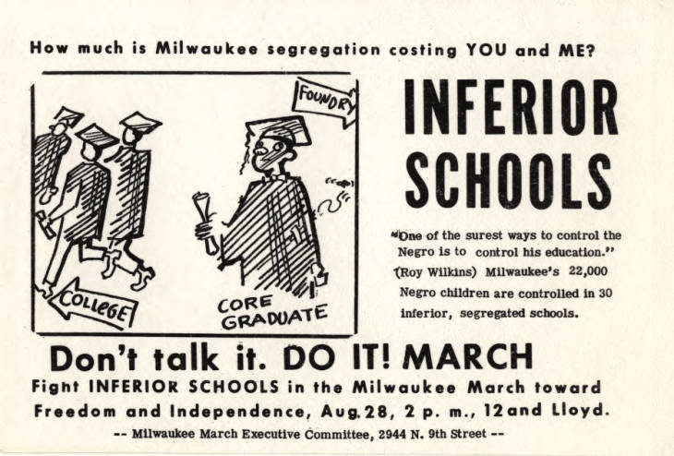
- Working with a partner, explain the main message of the cartoon in your own words. “Core” refers to Milwaukee’s Black neighborhood; “foundry” is a factory where people make things out of metal.

- List adjectives that describe the emotions the characters in the cartoon might be feeling.

- Which clues in the picture make you think that is what they are feeling?

- What does the quotation from Roy Wilkins (to the right of the cartoon) mean?

- Who is “in control” in Milwaukee?

- Who didn’t have control?

- What are some other words for control?

- Aside from education, list 3 things that will affect the life you’ll live as an adult:

- Which one is the most important? Explain why:

- On another sheet of paper, draw a cartoon illustrating a social issue that you care about. What message are you trying to get across? How does your cartoon communicate that main message?

9. RECRUITMENT FLIER #2:

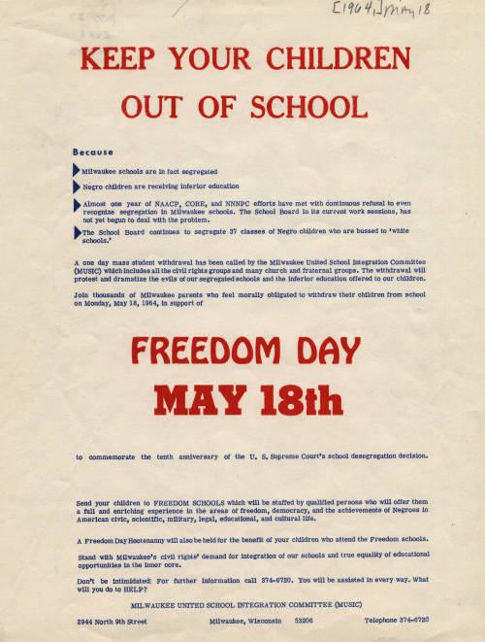
Use the 1964 “Keep Your Children Out of School” flier to answer the following questions
- Who created the flier and who was its target audience? What evidence do you see on the flier to support your answers?

- Creator:

- Audience:

B. List in your own words the problems that organizers point out on the flier. CIRCLE the 2 problems that you think are the most serious.

C. Think of issues that people are protesting today. Choose one. If you were asked to
boycott school in order to protest it, would you do it? Why or why not?

10. BUS BOYCOTT

Watch the News clip on school boycotts and segregation (May 18, 1964) http://wihist.org/1yrlmXx

- What’s happening during the first 2 minutes when there’s no sound? Make a list of the places and activities you see:

- If the video had been used on the TV news, an announcer would have been talking over the first minutes. What do you think would have been the announcer’s main points?

- Watch the brief interview with Lloyd Barbee. Why does he say the boycott is needed? Does he think it is succeeding?

- Do you think the man asking Barbee the questions supports the boycott, opposes it, or doesn’t take sides? Why do you think that?

11. WHY WE DEMONSTRATE FLIER
Read the December 1, 1963 NAACP Youth Council flier, “Why We Demonstrate” describing the protest against Big Boy Restaurant employment policies. Answer the questions below it.

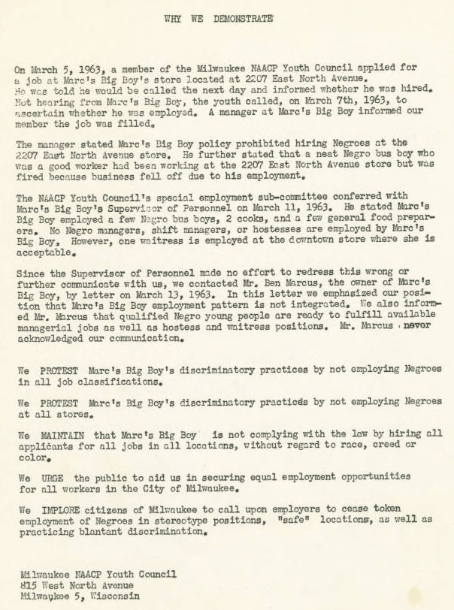
- What’s the main message of the flier? What is it trying to do?
- Who created it?

- Who is the intended audience?

- Turn each of its last 5 paragraphs into a short phrase that somebody younger than you could understand. Start each one with “Marc’s Big Boy should…”

  - Marc’s Big Boy should…

  - Marc’s Big Boy should…

  - Marc’s Big Boy should…

  - Marc’s Big Boy should…

  - Marc’s Big Boy should…

12. MARY ARMS INTERVIEW TRANSCRIPT (THE EAGLES CLUB PROTEST)

- “Oh that was scary. The Eagles Club, that’s my first time ever seeing the Ku Klux Klan, despite all I went through in Mississippi, was the first time I saw the Klan was, they were marching against us across the street on Wisconsin Avenue when we were marching for the Eagle’s Club. And then going out to Wauwatosa… we got cherry bombed and both of us just dazed, knocked us down, because when I woke up, ,it’s like, I always said when I woke up, I still had Junior’s hand. He was laying beside me. And we go up and took off running… it was when we were protesting out in Wauwatosa in front of Judge Cannon’s house. And, you know, naturally we had all the hecklers out there, throw things at you and threw that cherry bomb ad some kind of bomb, it just exploded. Or a firecracker, it was so loud it just knocked us flat. That was my first so-called injury. My mother used to, when we would be tear gassed, we’d come home hours afterwards and bring tears to their eyes. You know they could smell it when we come…”

- “We needed somebody to protect us from the police. The police would not protect us. They would let people come in the line and do things, you know so we needed protection… the name Commandos, I don’t know. I can’t even remember how I come up with the ame Commandos, but it was me. As a matter of fact, Shirley had to remind me, “Mary, you’re the one, you remember?” and I would say “yeah, but I, I don’t know what I was thinking about.” They looked like when they used to wear those tams and the combat boots, and the camouflage. That’s how they originally dressed. I said they looked like Commandos, you know, like the Marines or somebody, you know the Green Berets and of those people. So called them Commandos and it stuck…”

- “That was basically our job [the Commando-ettes], and watch out for, you know, different things we need to call to the Commandos attention. And we didn’t want people in the line with weapons or people that come to be violent. We heard of the police actually putting somebody in, just to cause a disruption so they can come in and beat us up. We had to watch out for things like that. That’s basically for the Commando-ettes… We fought just as hard. We were right there by their side.”

After listening to the oral history audio recording, answer the following questions. The transcript above will help.
- When was the interview conducted?

- When did the events that Arms describes happen?

- How many years passed between the two? Does that affect what we hear?

- How did Arms participate in Milwaukee’s Civil Rights Movement when she was a teenager? List her activities:

- Why did the Youth Council for the Commandos and was their purpose?

- Compare the interview format with other kinds of historical documents you’ve seen, like a letter, a newspaper article, or an autobiography? How does listening to an interview affect you differently than reading something?

13. “THE BATTLE FOR BUSING” 2013 NEWS STORY

Watch “Battle for Busing” September 9, 2013 video (http://wihist.org/1vFsM9V)

- At 1:21, Arthur Griffin starts talking about the segregated schools he attended, before busing. Name 3 examples he gives of how all-Black schools were worse off than all-white ones. Why were the city’s schools segregated?

- At 5:40, Dr. Rosaline Mickelson explains some things that happened when students began attending integrated schools. List 3 of them. Why would those things happen in an integrated school but not in a segregated one?

- Identify the part of the video that impressed or affected you the most. Why?

- Today, Milwaukee-area schools are segregated in same way the video describes at 9:45. How do you think that happened? What do you think should be done about it?

14. ANTI-BUSING LETTERS TO THE EDITOR, MILWAUKEE JOURNAL, December 29, 1983.

Read the anti busing letters sent to the Milwaukee Journal in 1983 and answer the following questions.

LETTER 1:
Just what kind of dictators do the Milwaukee School Board members think they are? Who are they to say that we in the rural communities must bus some of our children to Milwaukee schools?
Perhaps they don’t realize that they are trying to do more than exchange students from one side of Milwaukee to another. THey are trying to uproot students who have attended schools in a rural atmosphere and ship them to a completely different environment.
I personally feel that no way, come hell or high water, will my child ever be bused to Milwaukee to attend school. And I believe that as the integration issue progresses, the Milwaukee School Board will find many more parents such as myself, longtime residents of the “country,” who will oppose such a proposal.
If Milwaukee wishes to bus some of its children to outlying area schools and Milwaukee parents are willing to accept that, then I am sure those students will be welcome in our school systems. But don’t try to force us to send out children to Milwaukee. I, for one, will never permit it. - Darryl Gust, Pewaukee

LETTER 2:

I don’t want to go to school in Milwaukee! I like it where I am. The metro busing plan it unfair. They’re not going to force me to go to school so far away from home. I’m not getting up one hour earlier to ride a bus to school in an unfamiliar area: it’s unfair! Also, how much is this going to cost my parents? Are people aware of the money it takes to run buses 10-15 miles to and from schools every day?
Most school districts are concerned about their budgets. They “cut” good teachers every year because of lack of funds. Proposing to spend thousands of dollars per day to benefit mainly Milwaukee’s students lacks common sense, in my opinion.
The metro busing plan is an unnecessary waste of taxpayers’ money and disregards students’ needs and rights, both in the city and suburbs.
Perhaps school board members should get up one hour earlier to ride the bus to their jobs each day! - Julie Kreske (Greendale)

- List 2 reasons that Darryl Gust gives in Letter 1 for his opposition to busing students from the suburbs into the city.

- List 2 reasons given in Letter 2 for opposing busing in schools

- Should a higher level of government, like the state or a country, ever be able to overrule a lower one, like a town or a village? On what sorts of issues?

15. DEMOGRAPHICS MAPS ON THE SLIDES

- Examine Map 1. Where do most Black people live?

Where do most Hispanic people live?

Where do most white people live?

Are the races segregated in Milwaukee?

- If the Civil Rights Act made segregation illegal 50 years ago, how can this be?

- List 3 things that encourage segregated neighborhoods:

- Examine Map 2 the poverty rates map
Which neighborhoods have the most poverty?

Which ones have the least?

How does income correspond to housing segregation in the Milwaukee area?

- Until 1950, nearly all Milwaukee’s factories and jobs were located close to downtown, along railroad corridors and next to today’s I-94 highway. After the 1960s, many employers closed those century-old factories and relocated them to the suburbs. Why don’t inner-city residents commute out to jobs in places like Brookfield, Oak Creek, or Brown Deer?

