The Struggle for Justice on Tribal Lands
By NED BLACKHAWKNOV. 25, 2015
Photo
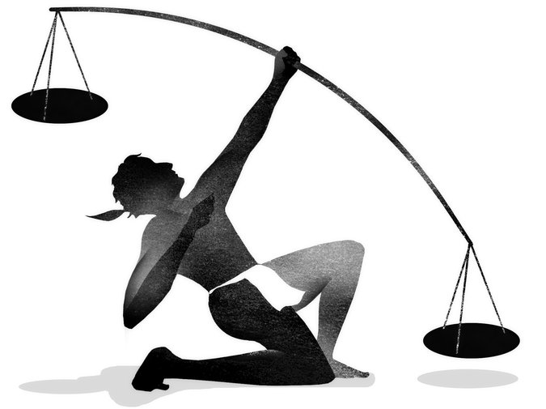
THE Thanksgiving we now celebrate began in partnership. Long after Pilgrim and Wampanoag families first shared their respective harvests, Native American communities continue to work, formally and informally, with many of their neighbors.

For example, before the Green Bay Packers take to Lambeau Field tomorrow night, thousands of fans will enter the historic stadium through its eastern entrance, named the Oneida Nation Gate in partnership with Green Bay’s closest tribal neighbor, the Oneida Nation of Wisconsin. Like many Indian tribes, the Oneida support numerous institutions of government, run schools and day care centers and employ hundreds of non-Indians.
But tribal governments now face a grave threat to this kind of partnership and to their very sovereignty. The danger comes from an action brought by the Dollar General Corporation. On Dec. 7, the Supreme Court is scheduled to hear oral arguments in a case regarding alleged sexual assaults by a Dollar General manager against a tribal minor, a 13-year-old who apprenticed in a store on Choctaw tribal lands in Mississippi. While working in partnership with non-Indians remains an important part of what tribal governments do, ensuring the welfare of tribal members is an essential function of their power. This case has the potential to undermine the authority of tribes to do both.
In keeping with the fraught legal and political relationship between Indians and the federal government, this case, Dollar General v. Mississippi Band of Choctaw Indians, is deeply rooted in our shared history. And as its focus has expanded, it is no longer exclusively about the child who was originally at its center.
Since its inception, the United States government has recognized that tribal governments have authority over their lands, their members and, in certain situations, those who enter their territories. This recognition is rooted in the Constitution’s Commerce Clause, in nearly two centuries of Supreme Court rulings and, crucially, in generations of customary practices between tribes and their neighbors. By asserting that tribes, despite generations of these partnerships with non-Indians, lack jurisdiction over businesses in Indian country, Dollar General is challenging this historic principle of American law.
This is not the first time tribes have fought to preserve their authority over non-Indians. For example, in 1978, the Supreme Court ruled in Oliphant v. Suquamish Indian Tribe that only the federal government could punish non-Indians for crimes committed on tribal lands.
But decades later, it was Native American survivors of domestic violence who led efforts to have Congress reauthorize previously lost forms of tribal authority over domestic violence. This victory came not only after growing concerns over lawlessness in Indian country but also after the harrowing testimony of survivors during the run-up to the 2013 reauthorization of the Violence Against Women Act.
Given this history, it is chilling that the Supreme Court has now agreed to hear Dollar General’s challenge to the sovereignty of the Mississippi Band of Choctaw Indians. Initially, the minor and his parents — barred from bringing criminal charges through tribal court — secured the molestation suspect’s expulsion from the reservation. No criminal charges were ever filed by the United States attorney’s office. The family then sought compensatory, civil damages within the tribe’s court system. Tribal and lower federal courts all agree that the tribe has the jurisdiction to hear the case. Dollar General, however, does not.
The arguments made by Dollar General’s lawyers are radical. They conflict with decades of settled precedent that recognize the ability of tribes to protect their citizens from noncriminal harms within their territories. Specifically, the corporation now argues that no tribe can protect its citizens in such civil cases, unless it is expressly authorized to do so by Congress.
A federal court agreed that Dollar General’s arguments were incorrect, but in appealing to the Supreme Court, Dollar General has created the potential of another Oliphant-style ruling that restricts tribal authority even further.
Dollar General, which has a market value of approximately $20 billion, once believed in tribal jurisdiction. In 2000, it received a business license from the Choctaw to open a store, executed binding leases recognizing tribal law, and maintained a commercial enterprise for years thereafter. Only when the tribe’s court system might hurt its bottom line, it seems, did the corporation turn to extreme and costly measures to ward off any form of restitution.
Dollar General is now asking the court to reverse essential tenets of federal Indian law. The ability of tribal governments to protect their citizens on reservation lands remains a long-recognized attribute of Indian sovereignty. As the Supreme Court held in 1981 in Montana v. United States, the doctrine of retained tribal sovereignty includes the power to exercise “some forms of civil jurisdiction over non-Indians on their reservations.”
Dollar General stands poised to become one of the century’s fiercest challengers to tribal communities. This case has the potential to jeopardize tribal governments’ ability to develop their economies, to make binding contracts, even to protect their citizens.
In pursuing profit above all else, Dollar General has darkened this holiday season. The Supreme Court should affirm the lower court rulings and preserve tribal authority in tribal lands. Otherwise, this Thanksgiving may be the last one during which we can give thanks for this long-recognized principle of American law.
Ned Blackhawk, a professor of history and American studies at Yale and the coordinator of the Yale Group for the Study of Native America, is the author of “Violence Over the Land: Indians and Empires in the Early American West.”
Follow The New York Times Opinion section on Facebook and Twitter, and sign up for theOpinion Today newsletter.
A version of this op-ed appears in print on November 25, 2015, on page A31 of the New York edition with the headline: The Struggle for Justice on Tribal Lands. Today's Paper|Subscribe

